09/06/2022

Mini Cal XML

<?xml version="1.0" encoding="utf-8"?>

<androidx.constraintlayout.widget.ConstraintLayout xmlns:android="http://schemas.android.com/apk/res/android"

xmlns:app="http://schemas.android.com/apk/res-auto"

xmlns:tools="http://schemas.android.com/tools"

android:layout_width="match_parent"

android:layout_height="match_parent"

tools:context=".MainActivity">

<LinearLayout

android:layout_width="409dp"

android:layout_height="729dp"

android:orientation="vertical"

tools:layout_editor_absoluteX="1dp"

tools:layout_editor_absoluteY="1dp">

<EditText

android:id="@+id/et1"

android:layout_width="match_parent"

android:layout_height="wrap_content"

android:ems="10"

android:inputType="textPersonName" />

<Button

android:id="@+id/btn1"

android:layout_width="130dp"

android:layout_height="wrap_content"

android:onClick="one"

android:text="1" />

<Button

android:id="@+id/btn2"

android:layout_width="130dp"

android:layout_height="wrap_content"

android:onClick="two"

android:text="2" />

<Button

android:id="@+id/btn3"

android:layout_width="130dp"

android:layout_height="wrap_content"

android:onClick="three"

android:text="3" />

<Button

android:id="@+id/btn4"

android:layout_width="130dp"

android:layout_height="wrap_content"

android:onClick="plus"

android:text="+" />

<Button

android:id="@+id/btn4"

android:layout_width="130dp"

android:layout_height="wrap_content"

android:onClick="minus"

android:text="-" />

<Button

android:id="@+id/btn5"

android:layout_width="130dp"

android:layout_height="wrap_content"

android:onClick="equ"

android:text="=" />

<Button

android:id="@+id/btn6"

android:layout_width="130dp"

android:layout_height="wrap_content"

android:onClick="clear"

android:text="CLEAR" />

</LinearLayout>

</androidx.constraintlayout.widget.ConstraintLayout>

Main

package rajagiri.cal;

import androidx.appcompat.app.AppCompatActivity;

import android.os.Bundle;

import android.view.View;

import android.widget.EditText;

public class MainActivity extends AppCompatActivity {

String sop="";

String op1="";

@Override

protected void onCreate(Bundle savedInstanceState) {

super.onCreate(savedInstanceState);

setContentView(R.layout.activity_main);

}

public void one(View v)

{

EditText e1;

e1 = (EditText)findViewById(R.id.et1);

String s = e1.getText().toString();

e1.setText(s+1);

}

public void two(View v)

{

EditText e1;

e1 = (EditText)findViewById(R.id.et1);

String s = e1.getText().toString();

e1.setText(s+2);

}

public void three(View v)

{

EditText e1;

e1 = (EditText)findViewById(R.id.et1);

String s = e1.getText().toString();

e1.setText(s+3);

}

public void plus(View v)

{

EditText e1;

e1 = (EditText)findViewById(R.id.et1);

op1 = e1.getText().toString();

e1.setText("");

sop = "+";

}

public void minus(View v)

{

EditText e1;

e1 = (EditText)findViewById(R.id.et1);

op1 = e1.getText().toString();

e1.setText("");

sop = "-";

}

public void equ(View v)

{

if(sop.equals("+"))

{

EditText e1;

e1 = (EditText)findViewById(R.id.et1);

int x = Integer.parseInt(e1.getText().toString());

x += Integer.parseInt(op1);

e1.setText(""+x);

}

else if(sop.equals("-"))

{

EditText e1;

e1 = (EditText)findViewById(R.id.et1);

int x = Integer.parseInt(e1.getText().toString());

x = Integer.parseInt(op1) - x;

e1.setText(""+x);

}

}

public void clear(View v)

{

EditText e1;

e1= (EditText)findViewById(R.id.et1);

e1.setText("");

sop="";

op1="";

}

}

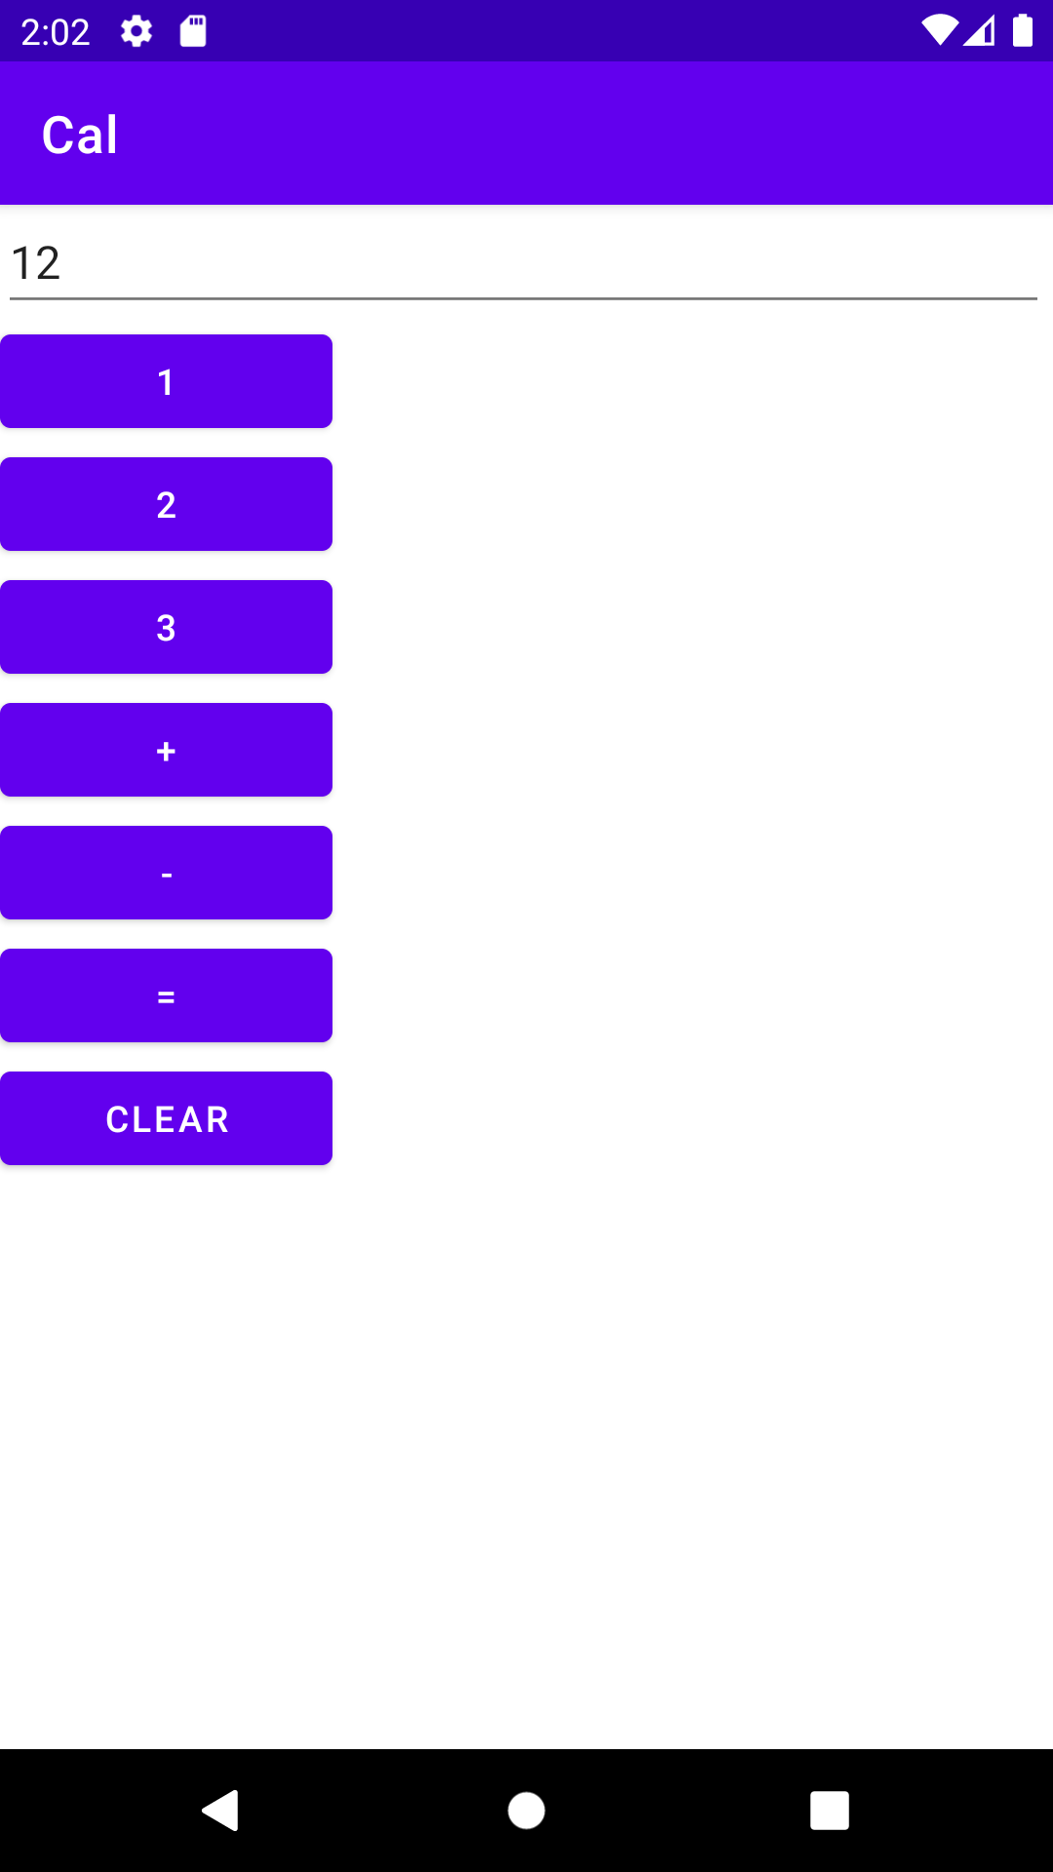

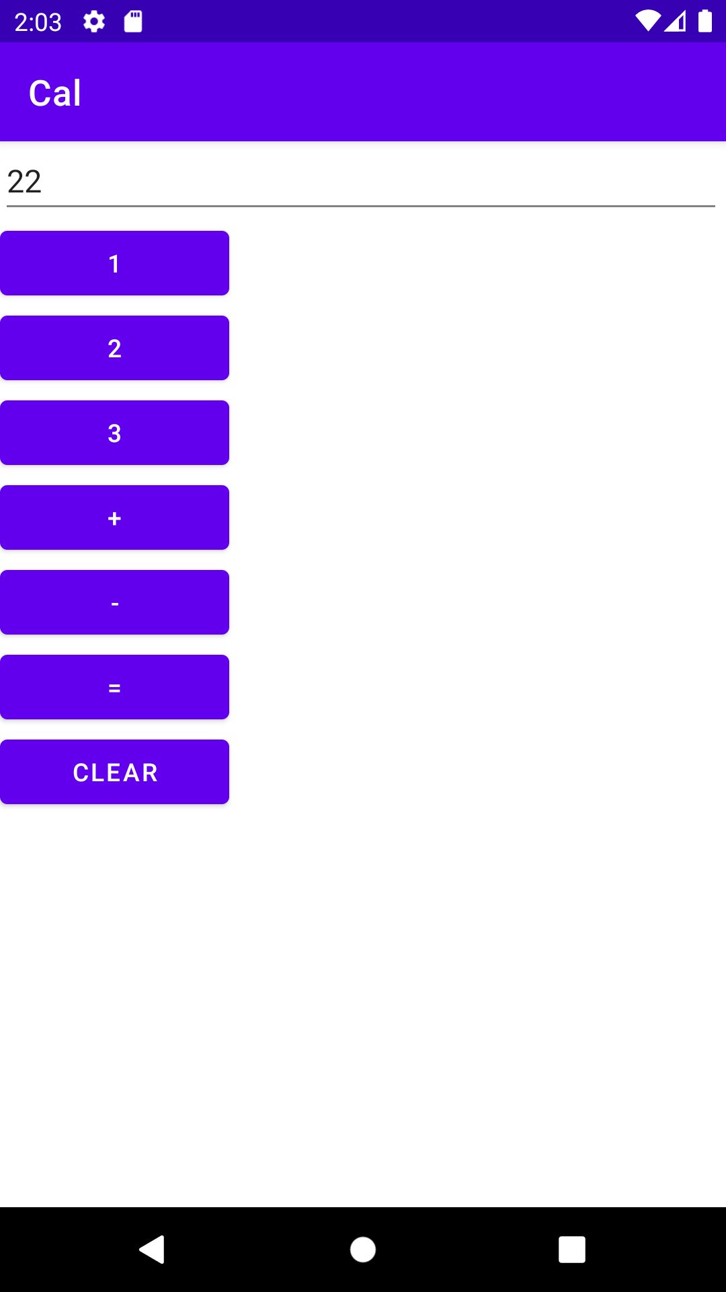

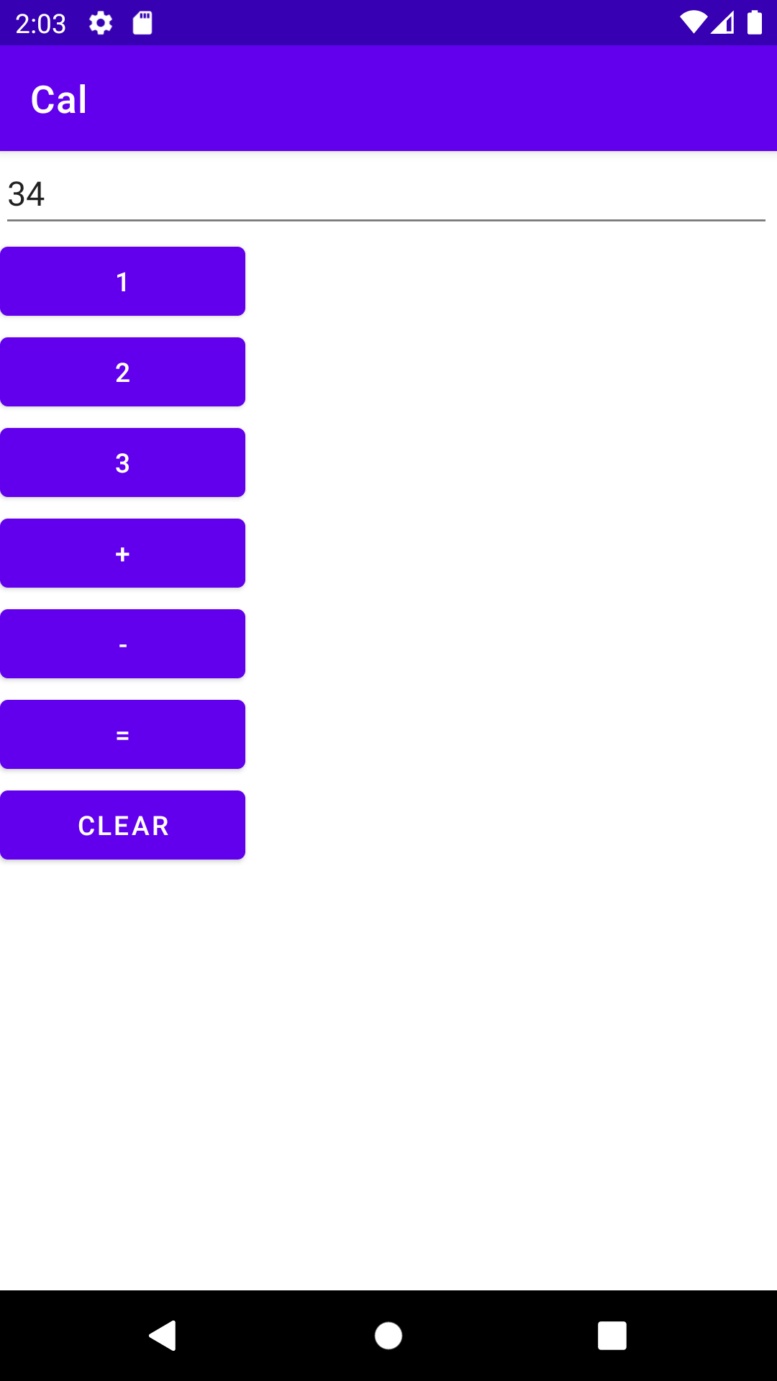

Numbers

Main

package com.example.texttest;

import androidx.appcompat.app.AppCompatActivity;

import android.os.Bundle;

import android.view.View;

import android.widget.Button;

import android.widget.EditText;

public class MainActivity extends AppCompatActivity {

@Override

protected void onCreate(Bundle savedInstanceState) {

super.onCreate(savedInstanceState);

setContentView(R.layout.activity_main);

}

public void one(View v)

{

EditText e1;

Button b;

b = (Button)findViewById(R.id.btn1);

e1= (EditText)findViewById(R.id.edt1);

String s = e1.getText().toString();

s = s + b.getText().toString();

e1.setText(s);

}

public void two(View v)

{

EditText e1;

e1= (EditText)findViewById(R.id.edt1);

String s = e1.getText().toString();

e1.setText(s+2);

}

public void three(View v)

{

EditText e1;

e1= (EditText)findViewById(R.id.edt1);

String s = e1.getText().toString();

e1.setText(s+3);

}

public void four(View v)

{

EditText e1;

e1= (EditText)findViewById(R.id.edt1);

String s = e1.getText().toString();

e1.setText(s+4);

}

public void clearText(View v)

{

EditText e1;

e1= (EditText)findViewById(R.id.edt1);

e1.setText("");

}

}

XML

<?xml version="1.0" encoding="utf-8"?>

<androidx.constraintlayout.widget.ConstraintLayout xmlns:android="http://schemas.android.com/apk/res/android"

xmlns:app="http://schemas.android.com/apk/res-auto"

xmlns:tools="http://schemas.android.com/tools"

android:layout_width="match_parent"

android:layout_height="match_parent"

tools:context=".MainActivity">

<LinearLayout

android:layout_width="405dp"

android:layout_height="437dp"

android:orientation="vertical"

tools:layout_editor_absoluteX="5dp"

tools:layout_editor_absoluteY="30dp">

<Button

android:id="@+id/btn1"

android:layout_width="match_parent"

android:layout_height="wrap_content"

android:background="#E91E63"

android:onClick="one"

android:text="1" />

<Button

android:id="@+id/btn2"

android:layout_width="match_parent"

android:layout_height="wrap_content"

android:onClick="two"

android:text="2" />

<Button

android:id="@+id/btn3"

android:layout_width="match_parent"

android:layout_height="wrap_content"

android:onClick="three"

android:text="3" />

<Button

android:id="@+id/btn4"

android:layout_width="match_parent"

android:layout_height="wrap_content"

android:onClick="four"

android:text="4" />

<EditText

android:id="@+id/edt1"

android:layout_width="match_parent"

android:layout_height="wrap_content"

android:ems="10"

android:inputType="textPersonName" />

<Button

android:id="@+id/btn5"

android:layout_width="match_parent"

android:layout_height="wrap_content"

android:onClick="clearText"

android:text="Clear" />

</LinearLayout>

</androidx.constraintlayout.widget.ConstraintLayout>

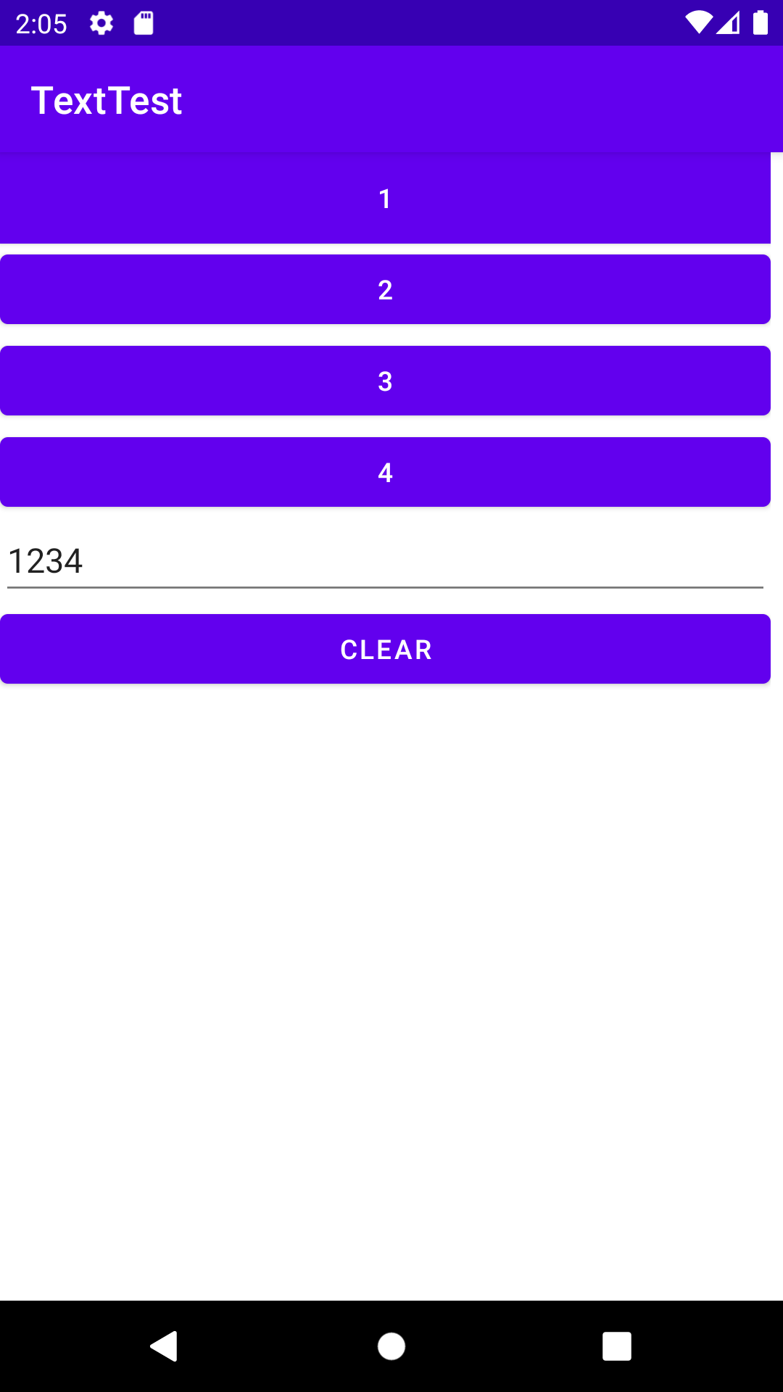

SumApp XML

<?xml version="1.0" encoding="utf-8"?>

<androidx.constraintlayout.widget.ConstraintLayout xmlns:android="http://schemas.android.com/apk/res/android"

xmlns:app="http://schemas.android.com/apk/res-auto"

xmlns:tools="http://schemas.android.com/tools"

android:layout_width="match_parent"

android:layout_height="match_parent"

tools:context=".MainActivity">

<LinearLayout

android:layout_width="409dp"

android:layout_height="354dp"

android:orientation="vertical"

tools:layout_editor_absoluteX="1dp"

tools:layout_editor_absoluteY="167dp"

tools:ignore="MissingConstraints">

<TextView

android:id="@+id/tv2"

android:layout_width="match_parent"

android:layout_height="wrap_content"

android:text="Enter 1st number" />

<EditText

android:id="@+id/et1"

android:layout_width="179dp"

android:layout_height="wrap_content"

android:ems="10"

android:inputType="textPersonName" />

<TextView

android:id="@+id/tv3"

android:layout_width="match_parent"

android:layout_height="wrap_content"

android:text="Enter 2nd number" />

<EditText

android:id="@+id/et2"

android:layout_width="178dp"

android:layout_height="wrap_content"

android:ems="10"

android:inputType="textPersonName" />

<Button

android:id="@+id/button"

android:layout_width="120dp"

android:layout_height="wrap_content"

android:onClick="onPlus"

android:text="+" />

<Button

android:id="@+id/button2"

android:layout_width="121dp"

android:layout_height="wrap_content"

android:onClick="onMinus"

android:text="-" />

<TextView

android:id="@+id/tv1"

android:layout_width="181dp"

android:layout_height="wrap_content" />

</LinearLayout>

</androidx.constraintlayout.widget.ConstraintLayout>

Main

package com.example.texttest;

import androidx.appcompat.app.AppCompatActivity;

import android.os.Bundle;

import android.view.View;

import android.widget.Button;

import android.widget.EditText;

public class MainActivity extends AppCompatActivity {

@Override

protected void onCreate(Bundle savedInstanceState) {

super.onCreate(savedInstanceState);

setContentView(R.layout.activity_main);

}

public void one(View v)

{

EditText e1;

Button b;

b = (Button)findViewById(R.id.btn1);

e1= (EditText)findViewById(R.id.edt1);

String s = e1.getText().toString();

s = s + b.getText().toString();

e1.setText(s);

}

public void two(View v)

{

EditText e1;

e1= (EditText)findViewById(R.id.edt1);

String s = e1.getText().toString();

e1.setText(s+2);

}

public void three(View v)

{

EditText e1;

e1= (EditText)findViewById(R.id.edt1);

String s = e1.getText().toString();

e1.setText(s+3);

}

public void four(View v)

{

EditText e1;

e1= (EditText)findViewById(R.id.edt1);

String s = e1.getText().toString();

e1.setText(s+4);

}

public void clearText(View v)

{

EditText e1;

e1= (EditText)findViewById(R.id.edt1);

e1.setText("");

}

}

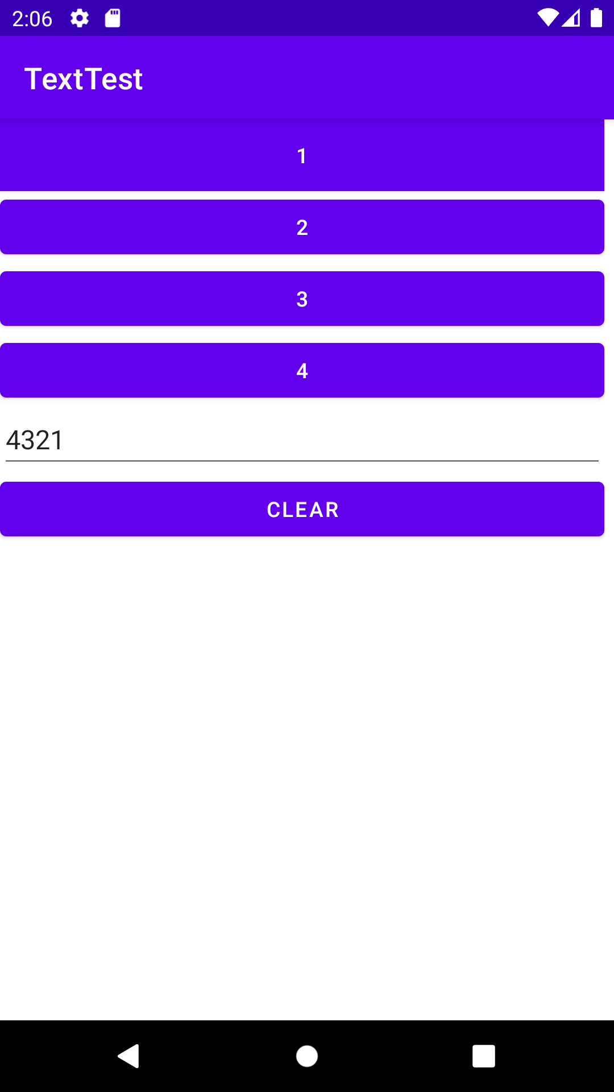

13/06/2022

AndroidManifest.xml

<?xml version="1.0" encoding="utf-8"?>

<manifest xmlns:android="http://schemas.android.com/apk/res/android"

xmlns:tools="http://schemas.android.com/tools"

package="rajagiri.act_2">

<application

android:allowBackup="true"

android:dataExtractionRules="@xml/data_extraction_rules"

android:fullBackupContent="@xml/backup_rules"

android:icon="@mipmap/ic_launcher"

android:label="@string/app_name"

android:roundIcon="@mipmap/ic_launcher_round"

android:supportsRtl="true"

android:theme="@style/Theme.ACT_2"

tools:targetApi="31">

<activity

android:name=".MainActivity"

android:exported="true">

<intent-filter>

<action android:name="android.intent.action.MAIN" />

<category android:name="android.intent.category.LAUNCHER" />

</intent-filter>

</activity>

<activity

android:name=".SecondActivity"

android:exported="true">

<intent-filter>

<action android:name="act.sec" />

<category android:name="android.intent.category.DEFAULT" />

</intent-filter>

</activity>

<activity

android:name=".ThirdActivity"

android:exported="true">

<intent-filter>

<action android:name="act.third" />

<category android:name="android.intent.category.DEFAULT" />

</intent-filter>

</activity>

</application>

</manifest>

MainActivity

package rajagiri.act_2;

import androidx.annotation.NonNull;

import androidx.appcompat.app.AppCompatActivity;

import android.content.Intent;

import android.os.Bundle;

import android.view.LayoutInflater;

import android.view.View;

public class MainActivity extends AppCompatActivity {

@Override

protected void onCreate(Bundle savedInstanceState) {

super.onCreate(savedInstanceState);

setContentView(R.layout.activity_main);

}

public void onSec(View v)

{

Intent ob = new Intent(this, SecondActivity.class);

startActivity(ob);

}

}

SecondActivity

package rajagiri.act_2;

import android.content.Intent;

import android.os.Bundle;

import android.view.View;

import androidx.appcompat.app.AppCompatActivity;

public class SecondActivity extends AppCompatActivity {

@Override

protected void onCreate(Bundle savedInstanceState) {

super.onCreate(savedInstanceState);

setContentView(R.layout.second);

}

public void onThird(View v)

{

Intent ob1 = new Intent(this, ThirdActivity.class);

startActivity(ob1);

}

}

ThirdActivity

package rajagiri.act_2;

import android.os.Bundle;

import android.view.View;

import androidx.appcompat.app.AppCompatActivity;

public class ThirdActivity extends AppCompatActivity {

@Override

protected void onCreate(Bundle savedInstanceState) {

super.onCreate(savedInstanceState);

setContentView(R.layout.third);

}

public void onHide(View v)

{

finish();

}

}

MainActivity.xml

<?xml version="1.0" encoding="utf-8"?>

<androidx.constraintlayout.widget.ConstraintLayout xmlns:android="http://schemas.android.com/apk/res/android"

xmlns:app="http://schemas.android.com/apk/res-auto"

xmlns:tools="http://schemas.android.com/tools"

android:layout_width="match_parent"

android:layout_height="match_parent"

tools:context=".MainActivity">

<LinearLayout

android:layout_width="409dp"

android:layout_height="729dp"

android:orientation="vertical"

tools:layout_editor_absoluteX="1dp"

tools:layout_editor_absoluteY="1dp">

<TextView

android:id="@+id/tv1"

android:layout_width="match_parent"

android:layout_height="wrap_content"

android:text="ONE" />

<Button

android:id="@+id/bhide"

android:layout_width="match_parent"

android:layout_height="wrap_content"

android:onClick="onSec"

android:text="Second" />

</LinearLayout>

</androidx.constraintlayout.widget.ConstraintLayout>

SecondActivity

<?xml version="1.0" encoding="utf-8"?>

<androidx.constraintlayout.widget.ConstraintLayout xmlns:android="http://schemas.android.com/apk/res/android"

xmlns:tools="http://schemas.android.com/tools"

android:layout_width="match_parent"

android:layout_height="match_parent"

tools:context=".SecondActivity">

<LinearLayout

android:layout_width="409dp"

android:layout_height="729dp"

android:orientation="vertical"

tools:layout_editor_absoluteX="1dp"

tools:layout_editor_absoluteY="1dp">

<Button

android:id="@+id/bthird"

android:layout_width="match_parent"

android:layout_height="wrap_content"

android:onClick="onThird"

android:text="THIRD" />

<TextView

android:id="@+id/tv2"

android:layout_width="match_parent"

android:layout_height="wrap_content"

android:text="TWO" />

</LinearLayout>

</androidx.constraintlayout.widget.ConstraintLayout>

ThirdActivity

<?xml version="1.0" encoding="utf-8"?>

<androidx.constraintlayout.widget.ConstraintLayout xmlns:android="http://schemas.android.com/apk/res/android"

xmlns:app="http://schemas.android.com/apk/res-auto"

xmlns:tools="http://schemas.android.com/tools"

android:layout_width="match_parent"

android:layout_height="match_parent"

tools:context=".ThirdActivity">

<LinearLayout

android:layout_width="409dp"

android:layout_height="729dp"

android:orientation="vertical"

tools:layout_editor_absoluteX="1dp"

tools:layout_editor_absoluteY="1dp">

<TextView

android:id="@+id/tv1"

android:layout_width="match_parent"

android:layout_height="wrap_content"

android:text="THREE" />

<Button

android:id="@+id/bhide"

android:layout_width="match_parent"

android:layout_height="wrap_content"

android:onClick="onHide"

android:text="HIDE" />

</LinearLayout>

</androidx.constraintlayout.widget.ConstraintLayout>

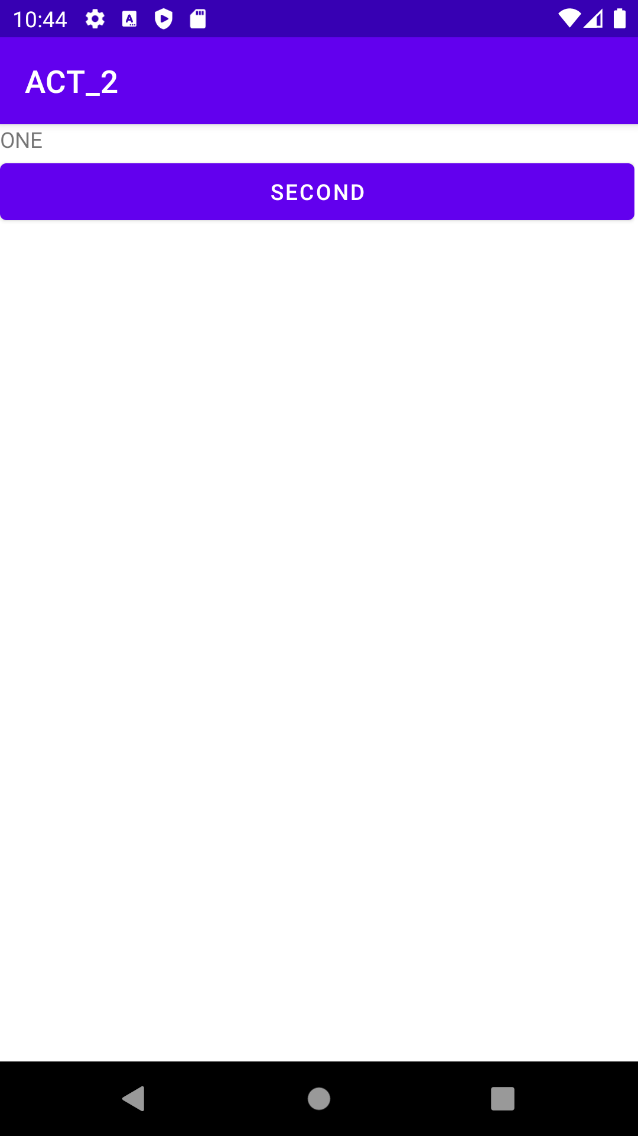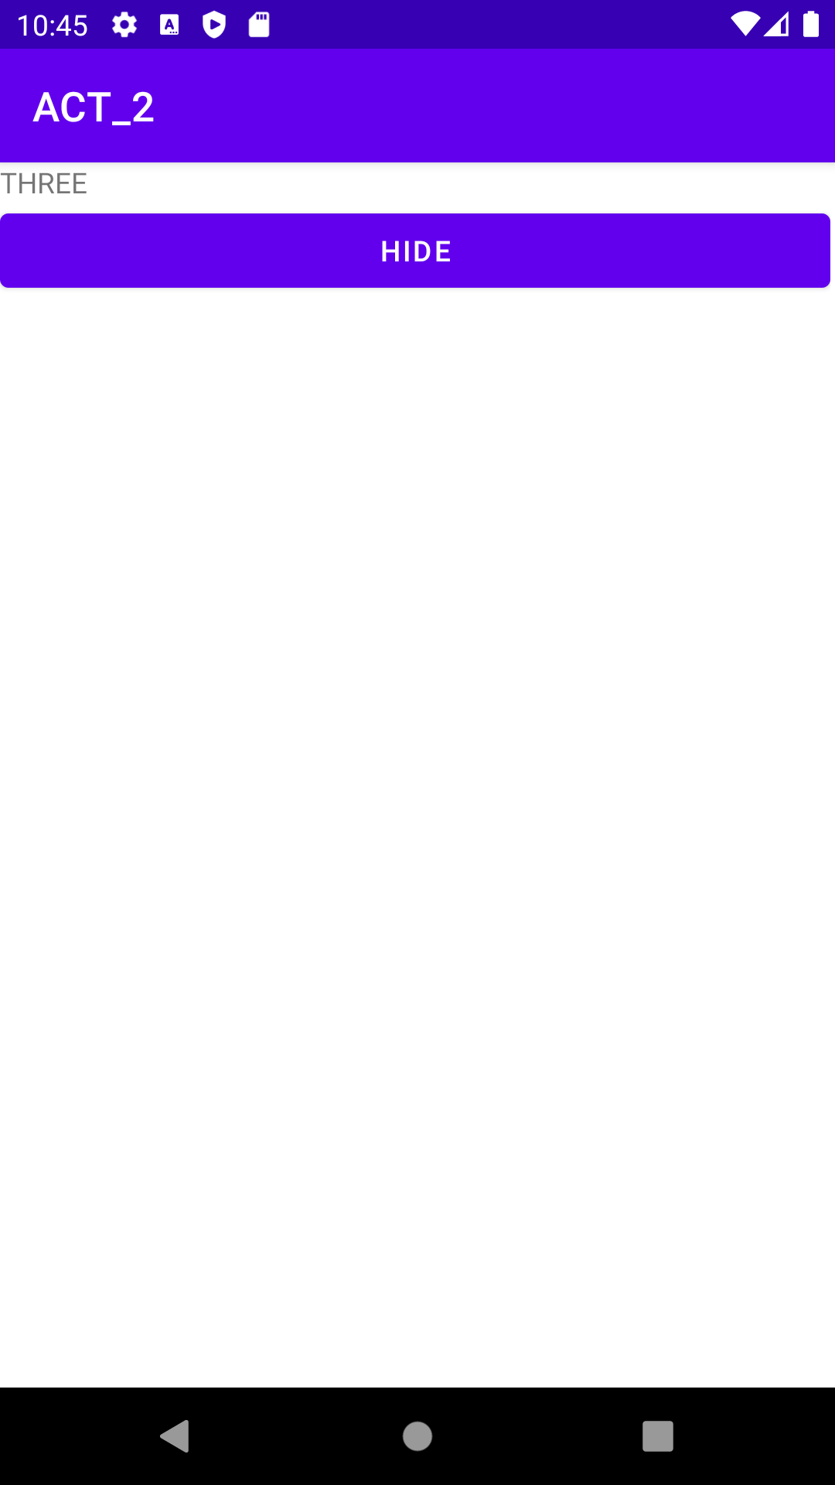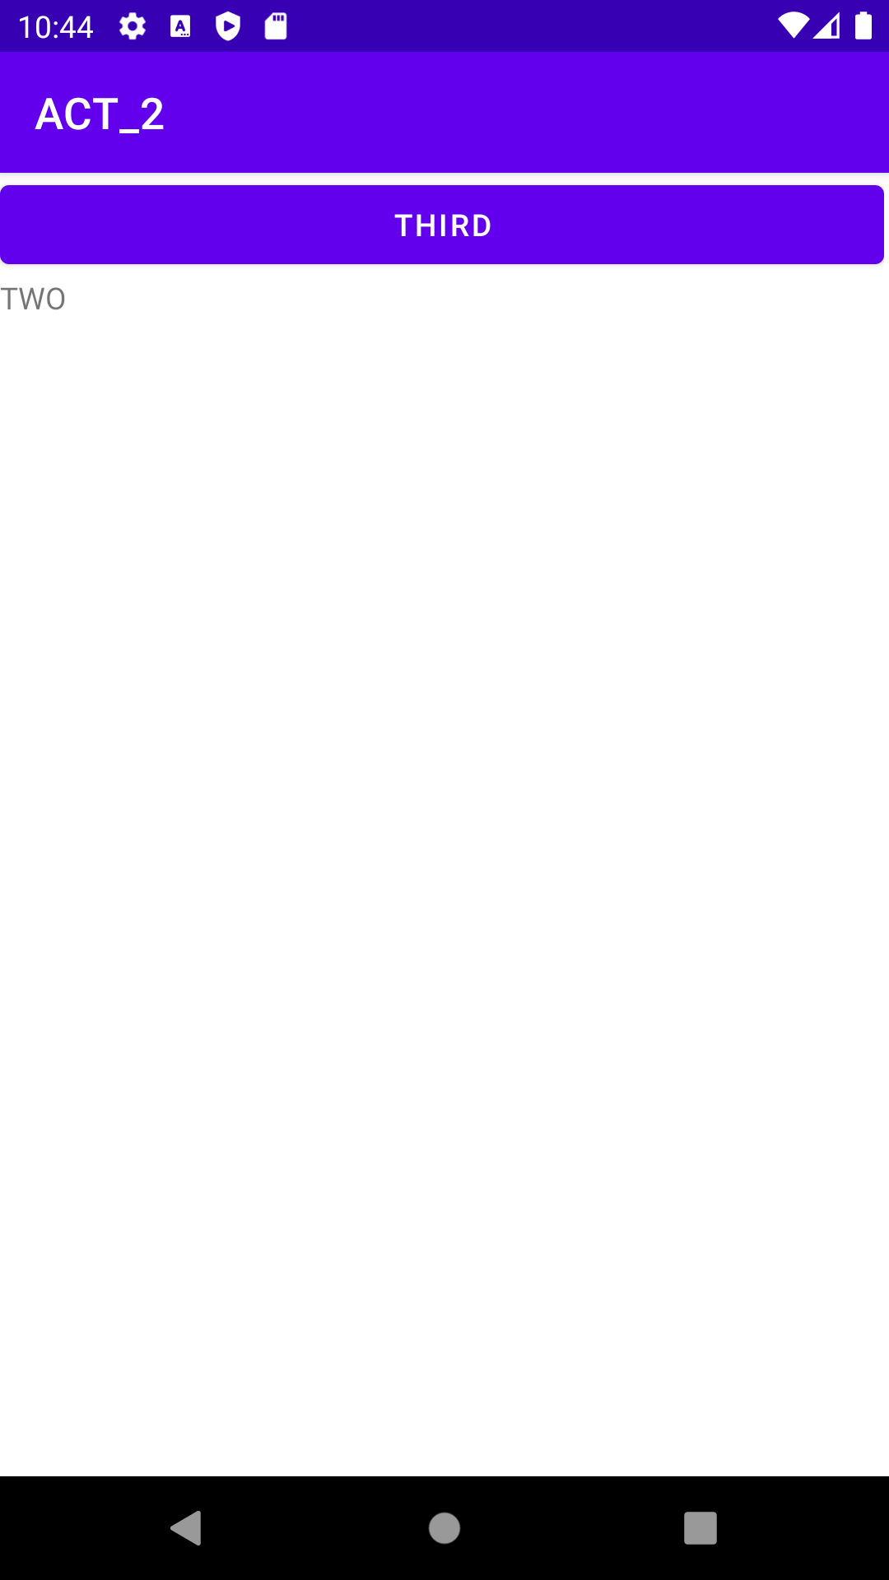

Manifest

<?xml version="1.0" encoding="utf-8"?>

<manifest xmlns:android="http://schemas.android.com/apk/res/android"

xmlns:tools="http://schemas.android.com/tools"

package="rajagiri.act_1">

<application

android:allowBackup="true"

android:dataExtractionRules="@xml/data_extraction_rules"

android:fullBackupContent="@xml/backup_rules"

android:icon="@mipmap/ic_launcher"

android:label="@string/app_name"

android:roundIcon="@mipmap/ic_launcher_round"

android:supportsRtl="true"

android:theme="@style/Theme.ACT_1"

tools:targetApi="31">

<activity

android:name=".MainActivity"

android:exported="true">

<intent-filter>

<action android:name="android.intent.action.MAIN" />

<category android:name="android.intent.category.LAUNCHER" />

</intent-filter>

</activity>

<activity

android:name=".SecondActivity"

android:exported="true">

<intent-filter>

<action android:name="act.sec" />

<category android:name="android.intent.category.DEFAULT" />

</intent-filter>

</activity>

</application>

</manifest>

MainActivity

package rajagiri.act_1;

import androidx.appcompat.app.AppCompatActivity;

import android.content.Intent;

import android.os.Bundle;

import android.view.*;

public class MainActivity extends AppCompatActivity {

@Override

protected void onCreate(Bundle savedInstanceState) {

super.onCreate(savedInstanceState);

setContentView(R.layout.activity_main);

}

public void onNext(View v)

{

Intent obj;

obj = new Intent(this, SecondActivity.class);

startActivity(obj);

}

public void onClose(View v)

{

finish();

}

}

SecondActivity

package rajagiri.act_1;

import android.os.Bundle;

import android.view.View;

import androidx.appcompat.app.AppCompatActivity;

public class SecondActivity extends AppCompatActivity {

@Override

protected void onCreate(Bundle savedInstanceState) {

super.onCreate(savedInstanceState);

setContentView(R.layout.second);

}

public void onHide(View v)

{

finish();

}

}

MainActivity.xml

<?xml version="1.0" encoding="utf-8"?>

<androidx.constraintlayout.widget.ConstraintLayout xmlns:android="http://schemas.android.com/apk/res/android"

xmlns:app="http://schemas.android.com/apk/res-auto"

xmlns:tools="http://schemas.android.com/tools"

android:layout_width="match_parent"

android:layout_height="match_parent"

tools:context=".MainActivity">

<LinearLayout

android:layout_width="409dp"

android:layout_height="729dp"

android:orientation="vertical"

tools:layout_editor_absoluteX="1dp"

tools:layout_editor_absoluteY="1dp">

<Button

android:id="@+id/bnext"

android:layout_width="match_parent"

android:layout_height="wrap_content"

android:backgroundTint="#5BA307"

android:onClick="onNext"

android:text="NEXT" />

<Button

android:id="@+id/bclose"

android:layout_width="match_parent"

android:layout_height="wrap_content"

android:backgroundTint="#D52D2D"

android:onClick="onClose"

android:text="CLOSE" />

</LinearLayout>

</androidx.constraintlayout.widget.ConstraintLayout>

SecondActivity.xml

<?xml version="1.0" encoding="utf-8"?>

<androidx.constraintlayout.widget.ConstraintLayout xmlns:android="http://schemas.android.com/apk/res/android"

xmlns:app="http://schemas.android.com/apk/res-auto"

xmlns:tools="http://schemas.android.com/tools"

android:layout_width="match_parent"

android:layout_height="match_parent"

tools:context=".SecondActivity">

<LinearLayout

android:layout_width="409dp"

android:layout_height="729dp"

android:orientation="vertical"

tools:layout_editor_absoluteX="1dp"

tools:layout_editor_absoluteY="1dp">

<Button

android:id="@+id/bhide"

android:layout_width="match_parent"

android:layout_height="wrap_content"

android:backgroundTint="#B18B18"

android:onClick="onHide"

android:text="HIDE" />

</LinearLayout>

</androidx.constraintlayout.widget.ConstraintLayout>

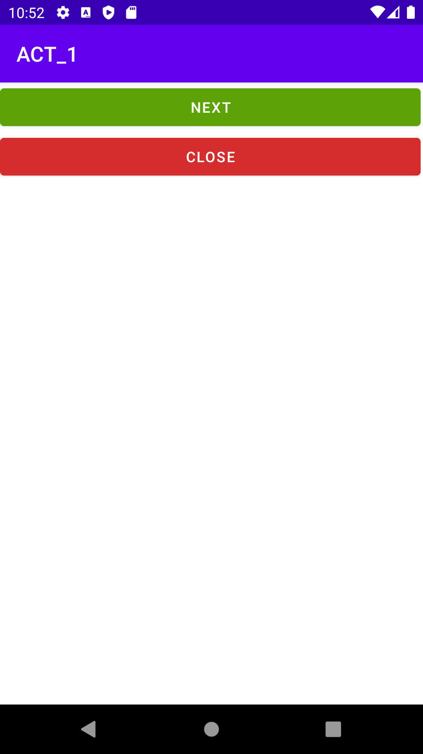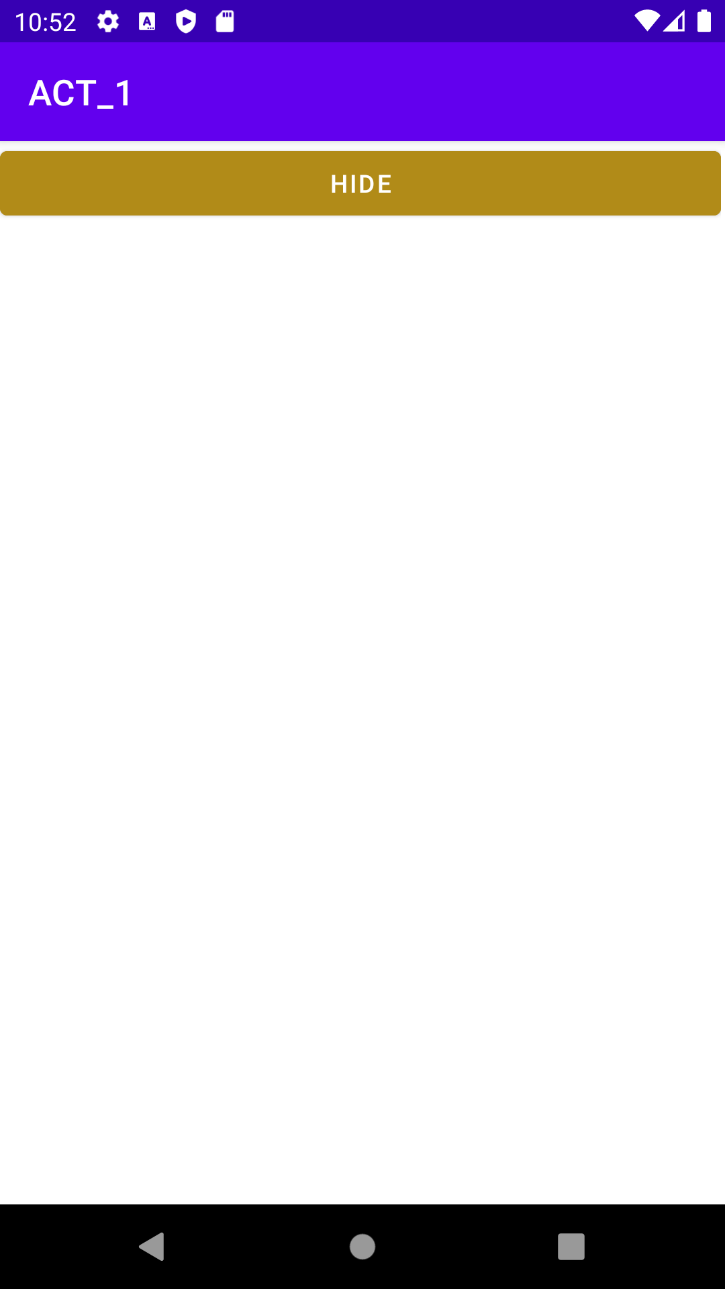

16/06/2022

# How to Change the Color of the Button

Main

package rajagiri.projbuttoncolor;

import androidx.appcompat.app.AppCompatActivity;

import android.graphics.Color;

import android.view.View;

import android.os.Bundle;

import java.util.Random;

public class MainActivity extends AppCompatActivity {

private int[] mColorChoices =

{ Color.BLUE, Color.CYAN,

Color.DKGRAY, Color.GRAY, Color.GREEN,

Color.LTGRAY, Color.MAGENTA, Color.RED,

Color.WHITE, Color.YELLOW };

protected void onCreate(Bundle savedInstanceState) {

super.onCreate(savedInstanceState);

setContentView(R.layout.activity_main);

}

public void randomizeColor(View button) {

Random generator = new Random();

int index = generator.nextInt(mColorChoices.length);

button.setBackgroundColor(mColorChoices[index]);

}

}

XML

<?xml version="1.0" encoding="utf-8"?>

<androidx.constraintlayout.widget.ConstraintLayout xmlns:android="http://schemas.android.com/apk/res/android"

xmlns:app="http://schemas.android.com/apk/res-auto"

xmlns:tools="http://schemas.android.com/tools"

android:layout_width="match_parent"

android:layout_height="match_parent"

tools:context=".MainActivity">

<LinearLayout

android:orientation="vertical"

android:layout_width="fill_parent"

android:layout_height="fill_parent">

<Button

android:layout_width="fill_parent"

android:layout_height="wrap_content"

android:onClick="randomizeColor"

android:text="Color One" />

<Button

android:layout_width="fill_parent"

android:layout_height="wrap_content"

android:onClick="randomizeColor"

android:text="Color Two" />

<TextView

android:layout_height="fill_parent"

android:layout_width="fill_parent"

android:textSize="48px"

android:gravity="center_horizontal"

android:text=" click on the button to see the color change "/>

</LinearLayout>

</androidx.constraintlayout.widget.ConstraintLayout>

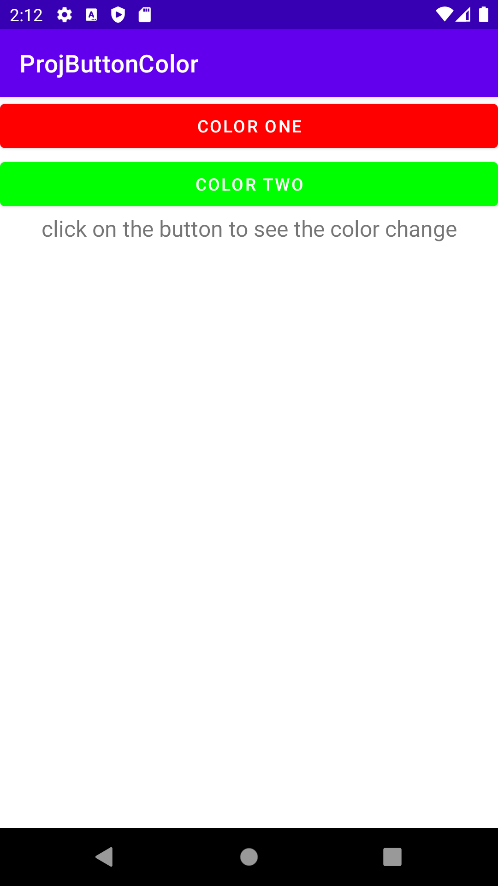

# How to Change the Color of the Background

Main

package com.example.projbgcolor;

import androidx.appcompat.app.AppCompatActivity;

import android.graphics.Color;

import android.os.Bundle;

import android.view.View;

import android.widget.TextView;

import java.util.Random;

public class MainActivity extends AppCompatActivity {

private int[] mColorChoices =

{ Color.BLACK, Color.BLUE, Color.CYAN,

Color.DKGRAY, Color.GRAY, Color.GREEN,

Color.LTGRAY, Color.MAGENTA, Color.RED,

Color.WHITE, Color.YELLOW };

private TextView mTextRegion;

protected void onCreate(Bundle savedInstanceState) {

super.onCreate(savedInstanceState);

setContentView(R.layout.activity_main);

mTextRegion = (TextView)findViewById(R.id.text_region);

}

public void randomizeColor(View button) {

Random generator = new Random();

int index = generator.nextInt(mColorChoices.length);

mTextRegion.setBackgroundColor(mColorChoices[index]);

}

}

XML

<?xml version="1.0" encoding="utf-8"?>

<androidx.constraintlayout.widget.ConstraintLayout xmlns:android="http://schemas.android.com/apk/res/android"

xmlns:app="http://schemas.android.com/apk/res-auto"

xmlns:tools="http://schemas.android.com/tools"

android:layout_width="match_parent"

android:layout_height="match_parent"

tools:context=".MainActivity">

<LinearLayout

android:orientation="vertical"

android:layout_width="fill_parent"

android:layout_height="fill_parent">

<Button

android:layout_height="wrap_content"

android:layout_width="fill_parent"

android:text="Button One"

android:onClick="randomizeColor"/>

<Button

android:layout_width="fill_parent"

android:layout_height="wrap_content"

android:onClick="randomizeColor"

android:text="Button two" />

<TextView

android:id="@+id/text_region"

android:layout_width="fill_parent"

android:layout_height="fill_parent"

android:gravity="center_horizontal"

android:text="click on the button to see the color change "

android:textSize="48px" />

</LinearLayout>

</androidx.constraintlayout.widget.ConstraintLayout>

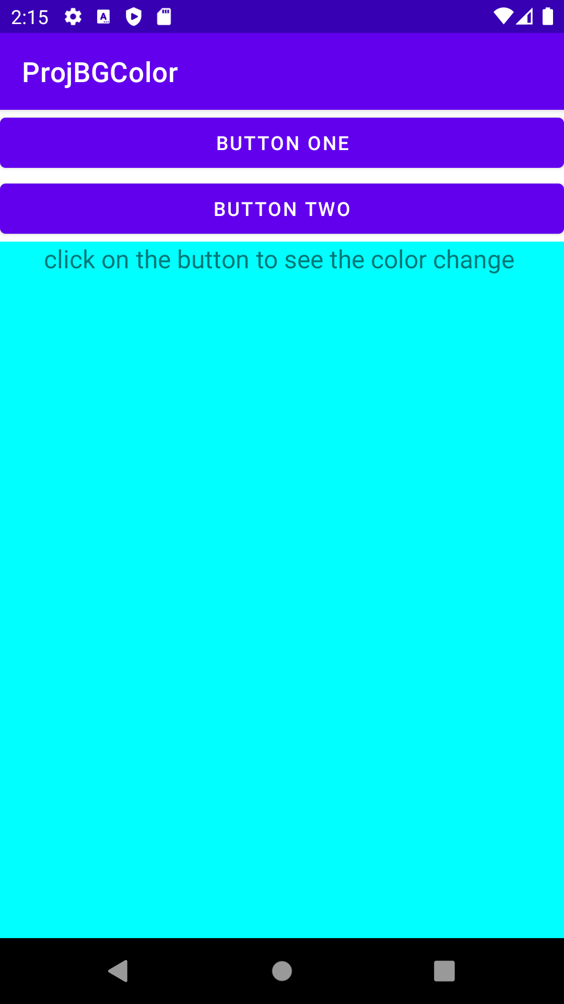

# How to Change the Color of the Button [Hybrid]

Main

package com.example.projhybuttoncolor;

import androidx.appcompat.app.AppCompatActivity;

import android.graphics.Color;

import android.os.Bundle;

import android.view.View;

import android.widget.Button;

import android.view.View.OnClickListener;

import java.util.Random;

public class MainActivity extends AppCompatActivity {

private View mColorRegion;

private int[] mColorChoices =

{ Color.BLACK, Color.BLUE, Color.CYAN,

Color.DKGRAY, Color.GRAY, Color.GREEN,

Color.LTGRAY, Color.MAGENTA, Color.RED,

Color.WHITE, Color.YELLOW };

@Override

protected void onCreate(Bundle savedInstanceState) {

super.onCreate(savedInstanceState);

setContentView(R.layout.activity_main);

mColorRegion = findViewById(R.id.color_region);

Button colorButton =

(Button)findViewById(R.id.color_button);

colorButton.setOnClickListener(new ColorRandomizer());

}

private void setRegionColor(int color) {

mColorRegion.setBackgroundColor(color);

}

private class ColorRandomizer implements OnClickListener {

/** Calls back to the outer class to set the color of View at the bottom. */

public void onClick(View clickedButton) {

Random generator = new Random();

int index = generator.nextInt(mColorChoices.length);

setRegionColor(mColorChoices[index]);

}

}

}

XML

<?xml version="1.0" encoding="utf-8"?>

<androidx.constraintlayout.widget.ConstraintLayout xmlns:android="http://schemas.android.com/apk/res/android"

xmlns:app="http://schemas.android.com/apk/res-auto"

xmlns:tools="http://schemas.android.com/tools"

android:layout_width="match_parent"

android:layout_height="match_parent"

tools:context=".MainActivity">

<LinearLayout

xmlns:android="http://schemas.android.com/apk/res/android"

android:orientation="vertical"

android:layout_width="fill_parent"

android:layout_height="fill_parent">

<Button

android:id="@+id/color_button"

android:layout_height="wrap_content"

android:layout_width="fill_parent"

android:text="Press"/>

<TextView

android:id="@+id/color_region"

android:layout_height="fill_parent"

android:layout_width="fill_parent"/>

</LinearLayout>

</androidx.constraintlayout.widget.ConstraintLayout>

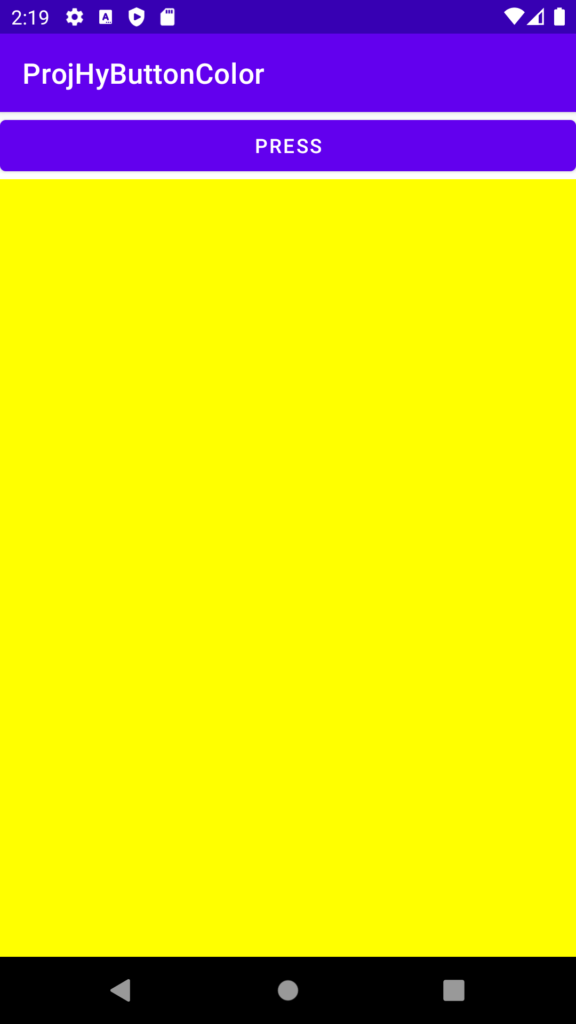

Interest Calculator

Main

package com.example.interestcal;

import androidx.appcompat.app.AppCompatActivity;

import android.os.Bundle;

import android.view.View;

import android.widget.EditText;

import android.widget.TextView;

public class MainActivity extends AppCompatActivity {

@Override

protected void onCreate(Bundle savedInstanceState) {

super.onCreate(savedInstanceState);

setContentView(R.layout.activity_main);

}

public void onCal(View v)

{

EditText t1,t2,t3;

TextView t4;

int y,r;

double a,f=0;

t1 = (EditText)findViewById(R.id.etn1);

t2 = (EditText)findViewById(R.id.etn2);

t3 = (EditText)findViewById(R.id.etn3);

t4 = (TextView)findViewById(R.id.tv4);

y = Integer.parseInt(t3.getText().toString());

r = Integer.parseInt(t2.getText().toString());

a = Double.parseDouble(t1.getText().toString());

for(int i = 0; i<y; i++)

{

f = (a*r)/100;

a = a+f;

}

t4.setText("Total Amount to pay = " + a);

}

}

XML

<?xml version="1.0" encoding="utf-8"?>

<androidx.constraintlayout.widget.ConstraintLayout xmlns:android="http://schemas.android.com/apk/res/android"

xmlns:app="http://schemas.android.com/apk/res-auto"

xmlns:tools="http://schemas.android.com/tools"

android:layout_width="match_parent"

android:layout_height="match_parent"

tools:context=".MainActivity">

<LinearLayout

android:layout_width="409dp"

android:layout_height="729dp"

android:orientation="vertical"

tools:layout_editor_absoluteX="1dp"

tools:layout_editor_absoluteY="1dp">

<TextView

android:id="@+id/tv1"

android:layout_width="match_parent"

android:layout_height="wrap_content"

android:text="Enter Loan Amount" />

<EditText

android:id="@+id/etn1"

android:layout_width="wrap_content"

android:layout_height="wrap_content"

android:ems="10"

android:inputType="numberDecimal" />

<TextView

android:id="@+id/tv2"

android:layout_width="match_parent"

android:layout_height="wrap_content"

android:text="Enter Interest rate" />

<EditText

android:id="@+id/etn2"

android:layout_width="wrap_content"

android:layout_height="wrap_content"

android:ems="10"

android:inputType="numberDecimal" />

<TextView

android:id="@+id/tv3"

android:layout_width="match_parent"

android:layout_height="wrap_content"

android:text="Enter no. years" />

<EditText

android:id="@+id/etn3"

android:layout_width="wrap_content"

android:layout_height="wrap_content"

android:ems="10"

android:inputType="numberSigned" />

<Button

android:id="@+id/bCal"

android:layout_width="match_parent"

android:layout_height="wrap_content"

android:onClick="onCal"

android:text="Calculate Total Amount" />

<TextView

android:id="@+id/tv4"

android:layout_width="match_parent"

android:layout_height="wrap_content"

android:textSize="24sp" />

</LinearLayout>

</androidx.constraintlayout.widget.ConstraintLayout>

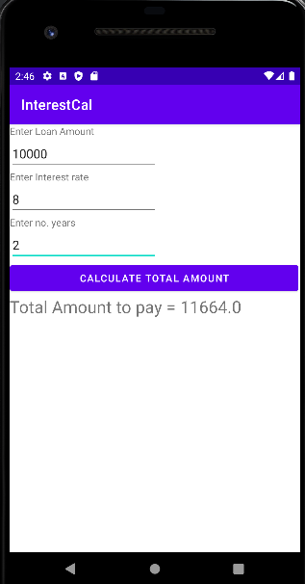

17/06/2022

Calculate sum and diff using 3 pages

Manifest

<?xml version="1.0" encoding="utf-8"?>

<manifest xmlns:android="http://schemas.android.com/apk/res/android"

xmlns:tools="http://schemas.android.com/tools"

package="com.example.calsumdiff">

<application

android:allowBackup="true"

android:dataExtractionRules="@xml/data_extraction_rules"

android:fullBackupContent="@xml/backup_rules"

android:icon="@mipmap/ic_launcher"

android:label="@string/app_name"

android:roundIcon="@mipmap/ic_launcher_round"

android:supportsRtl="true"

android:theme="@style/Theme.CalSumDiff"

tools:targetApi="31">

<activity

android:name=".MainActivity"

android:exported="true">

<intent-filter>

<action android:name="android.intent.action.MAIN" />

<category android:name="android.intent.category.LAUNCHER" />

</intent-filter>

</activity>

<activity

android:name=".SecondActivity"

android:exported="true">

<intent-filter>

<action android:name="android.intent.action.MAIN" />

<category android:name="android.intent.category.DEFAULT" />

</intent-filter>

</activity>

<activity

android:name=".ThirdActivity"

android:exported="true">

<intent-filter>

<action android:name="android.intent.action.MAIN" />

<category android:name="android.intent.category.DEFAULT" />

</intent-filter>

</activity>

</application>

</manifest>

Javapage 1

package com.example.calsumdiff;

import androidx.appcompat.app.AppCompatActivity;

import android.content.Intent;

import android.os.Bundle;

import android.view.View;

import android.widget.Button;

import android.widget.EditText;

public class MainActivity extends AppCompatActivity {

@Override

protected void onCreate(Bundle savedInstanceState) {

super.onCreate(savedInstanceState);

setContentView(R.layout.activity_main);

}

public void onCal(View v)

{

EditText e1,e2;

e1 = (EditText)findViewById(R.id.etn1);

e2 = (EditText)findViewById(R.id.etn2);

Intent ob = new Intent(getApplicationContext(), SecondActivity.class);

ob.putExtra("n11", e1.getText().toString());

ob.putExtra("n22", e2.getText().toString());

startActivity(ob);

}

}

XML page 1

<?xml version="1.0" encoding="utf-8"?>

<androidx.constraintlayout.widget.ConstraintLayout xmlns:android="http://schemas.android.com/apk/res/android"

xmlns:app="http://schemas.android.com/apk/res-auto"

xmlns:tools="http://schemas.android.com/tools"

android:layout_width="match_parent"

android:layout_height="match_parent"

tools:context=".MainActivity">

<TableLayout

android:layout_width="409dp"

android:layout_height="729dp"

tools:layout_editor_absoluteX="1dp"

tools:layout_editor_absoluteY="1dp">

<TableRow

android:layout_width="match_parent"

android:layout_height="match_parent" >

<TextView

android:id="@+id/tv1"

android:layout_width="wrap_content"

android:layout_height="wrap_content"

android:text="ONE" />

<EditText

android:id="@+id/etn1"

android:layout_width="wrap_content"

android:layout_height="wrap_content"

android:ems="10"

android:inputType="number" />

</TableRow>

<TableRow

android:layout_width="match_parent"

android:layout_height="match_parent" >

<TextView

android:id="@+id/tv2"

android:layout_width="wrap_content"

android:layout_height="wrap_content"

android:text="TWO" />

<EditText

android:id="@+id/etn2"

android:layout_width="wrap_content"

android:layout_height="wrap_content"

android:ems="10"

android:inputType="number" />

</TableRow>

<TableRow

android:layout_width="match_parent"

android:layout_height="match_parent" >

<Button

android:id="@+id/bCal"

android:layout_width="wrap_content"

android:layout_height="wrap_content"

android:onClick="onCal"

android:text="Calculate" />

</TableRow>

<TableRow

android:layout_width="match_parent"

android:layout_height="match_parent" />

</TableLayout>

</androidx.constraintlayout.widget.ConstraintLayout>

Java Page 2

package com.example.calsumdiff;

import android.content.Intent;

import android.os.Bundle;

import android.view.View;

import android.widget.EditText;

import androidx.appcompat.app.AppCompatActivity;

public class SecondActivity extends AppCompatActivity {

int a,b,c=0;

@Override

protected void onCreate(Bundle savedInstanceState) {

super.onCreate(savedInstanceState);

setContentView(R.layout.screen_two);

Intent ob1 = getIntent();

a = Integer.parseInt(ob1.getExtras().getString("n11"));

b = Integer.parseInt(ob1.getExtras().getString("n22"));

}

public void onSum(View v)

{

Intent obs = new Intent(getApplicationContext(), ThirdActivity.class);

obs.putExtra("n1", a);

obs.putExtra("n2", b);

c=a+b;

String s = "Sum: " + c;

obs.putExtra("n3", s);

startActivity(obs);

}

public void onDiff(View v)

{

Intent obd = new Intent(getApplicationContext(), ThirdActivity.class);

obd.putExtra("n1", a);

obd.putExtra("n2", b);

c=a-b;

String s = "Difference: " + c;

obd.putExtra("n3", s);

startActivity(obd);

}

}

XML page 2

<?xml version="1.0" encoding="utf-8"?>

<androidx.constraintlayout.widget.ConstraintLayout xmlns:android="http://schemas.android.com/apk/res/android"

xmlns:tools="http://schemas.android.com/tools"

android:layout_width="match_parent"

android:layout_height="match_parent">

<LinearLayout

android:layout_width="409dp"

android:layout_height="729dp"

android:orientation="vertical"

tools:layout_editor_absoluteX="1dp"

tools:layout_editor_absoluteY="1dp">

<Button

android:id="@+id/bSum"

android:layout_width="match_parent"

android:layout_height="wrap_content"

android:onClick="onSum"

android:text="SUM" />

<Button

android:id="@+id/bDiff"

android:layout_width="match_parent"

android:layout_height="wrap_content"

android:onClick="onDiff"

android:text="Difference" />

</LinearLayout>

</androidx.constraintlayout.widget.ConstraintLayout>

Java Page 3

package com.example.calsumdiff;

import android.content.Intent;

import android.os.Bundle;

import android.view.View;

import android.widget.EditText;

import android.widget.TextView;

import androidx.appcompat.app.AppCompatActivity;

public class ThirdActivity extends AppCompatActivity {

@Override

protected void onCreate(Bundle savedInstanceState) {

super.onCreate(savedInstanceState);

setContentView(R.layout.screen_three);

TextView e1,e2,e3;

e1 = (TextView)findViewById(R.id.tv3);

e2 = (TextView)findViewById(R.id.tv4);

e3 = (TextView)findViewById(R.id.tv5);

Intent ob = getIntent();

e1.setText("Number One: "+ob.getExtras().getInt("n1"));

e2.setText("Number Two: "+ob.getExtras().getInt("n2"));

e3.setText(ob.getExtras().getString("n3"));

}

}

XML Page 3

<?xml version="1.0" encoding="utf-8"?>

<androidx.constraintlayout.widget.ConstraintLayout xmlns:android="http://schemas.android.com/apk/res/android"

xmlns:tools="http://schemas.android.com/tools"

android:layout_width="match_parent"

android:layout_height="match_parent">

<LinearLayout

android:layout_width="409dp"

android:layout_height="729dp"

android:orientation="vertical"

tools:layout_editor_absoluteX="1dp"

tools:layout_editor_absoluteY="1dp">

<TextView

android:id="@+id/tv3"

android:layout_width="match_parent"

android:layout_height="wrap_content"

android:textSize="20sp" />

<TextView

android:id="@+id/tv4"

android:layout_width="match_parent"

android:layout_height="wrap_content"

android:textSize="20sp"

/>

<TextView

android:id="@+id/tv5"

android:layout_width="match_parent"

android:layout_height="wrap_content"

android:textSize="20sp"

/>

</LinearLayout>

</androidx.constraintlayout.widget.ConstraintLayout>

BMI Calculator

XML

<?xml version="1.0" encoding="utf-8"?>

<androidx.constraintlayout.widget.ConstraintLayout xmlns:android="http://schemas.android.com/apk/res/android"

xmlns:app="http://schemas.android.com/apk/res-auto"

xmlns:tools="http://schemas.android.com/tools"

android:layout_width="match_parent"

android:layout_height="match_parent"

tools:context=".MainActivity">

<LinearLayout

android:layout_width="409dp"

android:layout_height="729dp"

android:orientation="vertical"

tools:layout_editor_absoluteX="1dp"

tools:layout_editor_absoluteY="1dp">

<TableLayout

android:layout_width="match_parent"

android:layout_height="102dp">

<TableRow

android:layout_width="match_parent"

android:layout_height="match_parent">

<TextView

android:id="@+id/tv1"

android:layout_width="110dp"

android:layout_height="wrap_content"

android:text=" Height (Cm)"

android:textSize="16sp" />

<EditText

android:id="@+id/etn1"

android:layout_width="300dp"

android:layout_height="wrap_content"

android:ems="10"

android:inputType="numberSigned" />

</TableRow>

<TableRow

android:layout_width="match_parent"

android:layout_height="match_parent">

<TextView

android:id="@+id/tv2"

android:layout_width="wrap_content"

android:layout_height="wrap_content"

android:text=" Weight (Kg)"

android:textSize="16sp" />

<EditText

android:id="@+id/etn2"

android:layout_width="wrap_content"

android:layout_height="wrap_content"

android:ems="10"

android:inputType="numberSigned" />

</TableRow>

</TableLayout>

<LinearLayout

android:layout_width="match_parent"

android:layout_height="match_parent"

android:orientation="vertical">

<View

android:id="@+id/divider6"

android:layout_width="match_parent"

android:layout_height="10dp"

android:background="?android:attr/listDivider"

android:backgroundTint="#078DCA" />

<View

android:id="@+id/divider5"

android:layout_width="match_parent"

android:layout_height="10dp"

android:background="?android:attr/listDivider"

android:backgroundTint="#078DCA" />

<TableRow

android:layout_width="match_parent"

android:layout_height="52dp">

<Button

android:id="@+id/bCal"

android:layout_width="match_parent"

android:layout_height="wrap_content"

android:backgroundTint="#4E4949"

android:onClick="onCal"

android:text="CALCULATE" />

</TableRow>

<TextView

android:id="@+id/tv3"

android:layout_width="match_parent"

android:layout_height="102dp" />

<View

android:id="@+id/divider8"

android:layout_width="match_parent"

android:layout_height="10dp"

android:background="?android:attr/listDivider"

android:foregroundTint="#EDB407" />

<TextView

android:id="@+id/tv4"

android:layout_width="match_parent"

android:layout_height="135dp" />

<View

android:id="@+id/divider9"

android:layout_width="match_parent"

android:layout_height="10dp"

android:background="?android:attr/listDivider"

android:foregroundTint="#EDB407" />

<TextView

android:id="@+id/tv5"

android:layout_width="match_parent"

android:layout_height="136dp" />

</LinearLayout>

</LinearLayout>

</androidx.constraintlayout.widget.ConstraintLayout>

MAIN

package com.example.test;

import androidx.appcompat.app.AppCompatActivity;

import android.annotation.SuppressLint;

import android.os.Bundle;

import android.view.View;

import android.widget.EditText;

import android.widget.TextView;

public class MainActivity extends AppCompatActivity {

@Override

protected void onCreate(Bundle savedInstanceState) {

super.onCreate(savedInstanceState);

setContentView(R.layout.activity_main);

}

@SuppressLint("SetTextI18n")

public void onCal(View v)

{

EditText et1,et2;

TextView tv1,tv2,tv3;

float a,b,bmi;

et1 = (EditText)findViewById(R.id.etn1);

et2 = (EditText)findViewById(R.id.etn2);

tv1 = (TextView)findViewById(R.id.tv3);

tv2 = (TextView)findViewById(R.id.tv4);

tv3 = (TextView)findViewById(R.id.tv5);

a = Integer.parseInt(et1.getText().toString());

b = Integer.parseInt(et2.getText().toString());

a/=100;

bmi=b/(a*a);

String status1="", status2="", status3="";

if(bmi<=18.5){

status1 = "Under Weight";

status2 = "Your optimum weight should be "+ (float)(a*a*24);

status3 = "You need to gain at least " + (float)(b-(a*a*24));

}

else if(bmi>18.5 && bmi<25)

{

status1="in Healthy Range";

status2 = "You are at your optimum weight";

status3 = "Maintain your weight";

}

else if(bmi>=25 && bmi<30)

{

status1="Over Weight";

status2 = "Your optimum weight should be " + (float)(a*a*24);

status3 = "You need to lose at least " + (float)((a*a*24) -b);

}

else if(bmi >= 30)

{

status1="Obesity";

status2 = "Your optimum weight should be " + (float)(a*a*24);

status3 = "You need to lose at least " + (float)((a*a*24) -b);

}

tv1.setText("Your BMI is "+ bmi +" and you are " + status1);

tv2.setText(status2);

tv3.setText(status3);

}

}

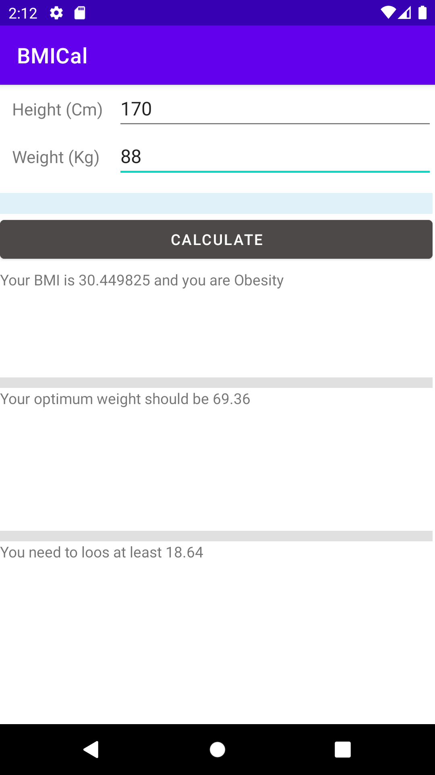

Company Wage Calculator

XML

<?xml version="1.0" encoding="utf-8"?>

<androidx.constraintlayout.widget.ConstraintLayout xmlns:android="http://schemas.android.com/apk/res/android"

xmlns:app="http://schemas.android.com/apk/res-auto"

xmlns:tools="http://schemas.android.com/tools"

android:layout_width="match_parent"

android:layout_height="match_parent"

tools:context=".MainActivity">

<LinearLayout

android:layout_width="409dp"

android:layout_height="729dp"

android:orientation="vertical"

tools:layout_editor_absoluteX="1dp"

tools:layout_editor_absoluteY="1dp" >

<TableRow

android:layout_width="match_parent"

android:layout_height="55dp">

<TextView

android:id="@+id/tv1"

android:layout_width="wrap_content"

android:layout_height="37dp"

android:text="Number of hours done: "

android:textSize="18sp" />

<EditText

android:id="@+id/etn1"

android:layout_width="wrap_content"

android:layout_height="wrap_content"

android:ems="10"

android:inputType="number" />

</TableRow>

<TableRow

android:layout_width="match_parent"

android:layout_height="64dp">

<TextView

android:id="@+id/tv2"

android:layout_width="188dp"

android:layout_height="37dp"

android:text="Hourly Rate: "

android:textSize="18sp" />

<EditText

android:id="@+id/etn2"

android:layout_width="wrap_content"

android:layout_height="wrap_content"

android:ems="10"

android:inputType="number" />

</TableRow>

<TableRow

android:layout_width="match_parent"

android:layout_height="64dp">

<Button

android:id="@+id/onCal"

android:layout_width="match_parent"

android:layout_height="wrap_content"

android:onClick="onCal"

android:text="CALCULATE WAGE" />

</TableRow>

<TextView

android:id="@+id/tv3"

android:layout_width="match_parent"

android:layout_height="40dp"

android:textSize="18sp" />

</LinearLayout>

</androidx.constraintlayout.widget.ConstraintLayout>

**MAIN**

package com.example.test;

import androidx.appcompat.app.AppCompatActivity;

import android.annotation.SuppressLint;

import android.os.Bundle;

import android.view.View;

import android.widget.EditText;

import android.widget.TextView;

public class MainActivity extends AppCompatActivity {

@Override

protected void onCreate(Bundle savedInstanceState) {

super.onCreate(savedInstanceState);

setContentView(R.layout.activity_main);

}

@SuppressLint("SetTextI18n")

public void onCal(View v)

{

EditText et1,et2;

TextView tv1;

int h,r;

float wp=0;

et1 = (EditText)findViewById(R.id.etn1);

et2 = (EditText)findViewById(R.id.etn2);

tv1 = (TextView)findViewById(R.id.tv3);

h = Integer.parseInt(et1.getText().toString());

r = Integer.parseInt(et2.getText().toString());

if(h<=39)

wp = h*r;

else if(h<=50)

wp = (float) ((r*39) + (h-39)*(r*1.12));

else

wp = (float) ((r*39) + (11*(r*1.12)) + ((r*1.15)*(h-50)));

tv1.setText("Wage = " + wp);

}

}

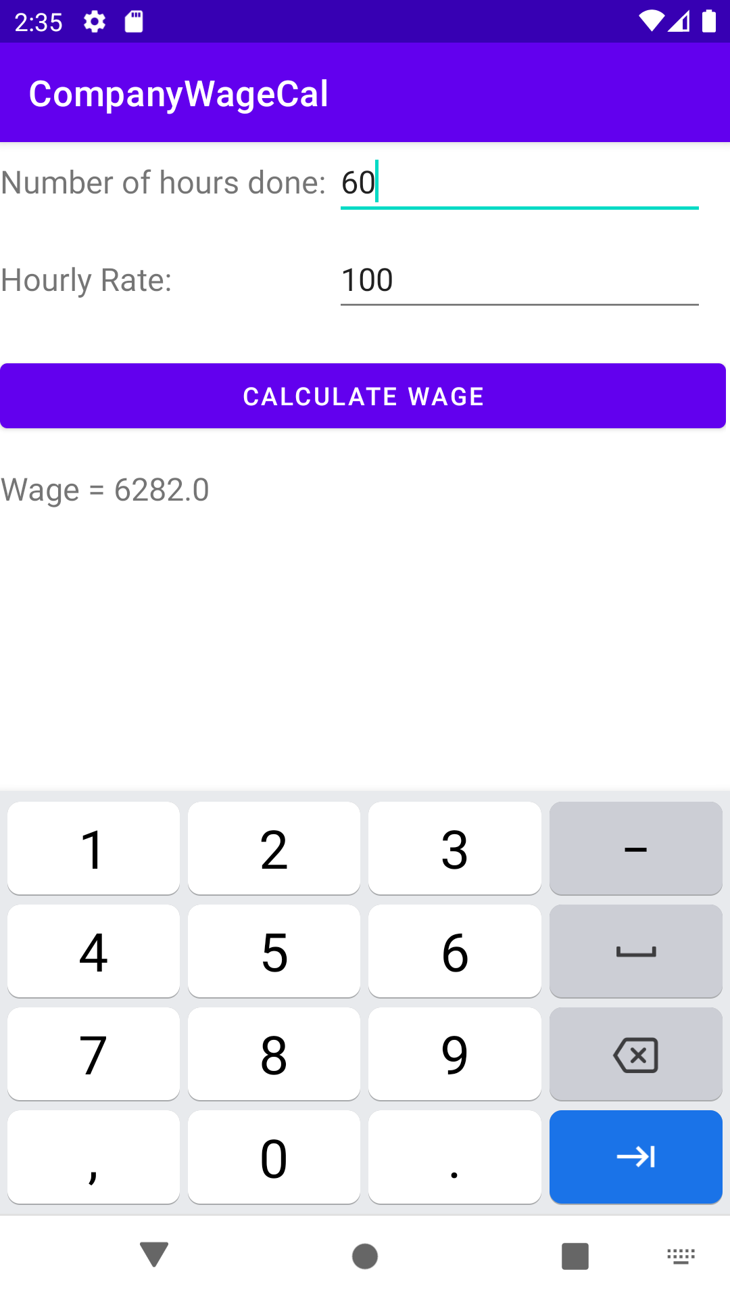

Q) Create an App to cal sum by passing values and returning output.

MAIN

package com.example.sum;

import androidx.appcompat.app.AppCompatActivity;

import android.content.Intent;

import android.os.Bundle;

import android.view.View;

import android.widget.EditText;

import android.widget.TextView;

public class MainActivity extends AppCompatActivity {

@Override

protected void onCreate(Bundle savedInstanceState) {

super.onCreate(savedInstanceState);

setContentView(R.layout.activity_main);

}

public void onCal(View v)

{

EditText e1,e2;

e1 = (EditText)findViewById(R.id.etn1);

e2 = (EditText)findViewById(R.id.etn2);

Intent IS = new Intent(this,SecondActivity.class);

IS.putExtra("1",e1.getText().toString());

IS.putExtra("2",e2.getText().toString());

startActivityForResult(IS,1);

}

protected void onActivityResult(int rq, int a, Intent data)

{

super.onActivityResult(rq, a, data);

TextView tv = (TextView)findViewById(R.id.textView);

if(a == RESULT_OK)

tv.setText(data.getData().toString());

}

}

MAIN XML

<?xml version="1.0" encoding="utf-8"?>

<androidx.constraintlayout.widget.ConstraintLayout xmlns:android="http://schemas.android.com/apk/res/android"

xmlns:app="http://schemas.android.com/apk/res-auto"

xmlns:tools="http://schemas.android.com/tools"

android:id="@+id/tv1"

android:layout_width="match_parent"

android:layout_height="match_parent"

tools:context=".MainActivity">

<LinearLayout

android:layout_width="409dp"

android:layout_height="729dp"

android:orientation="vertical"

tools:layout_editor_absoluteX="1dp"

tools:layout_editor_absoluteY="1dp">

<EditText

android:id="@+id/etn1"

android:layout_width="match_parent"

android:layout_height="wrap_content"

android:ems="10"

android:inputType="number" />

<EditText

android:id="@+id/etn2"

android:layout_width="match_parent"

android:layout_height="wrap_content"

android:ems="10"

android:inputType="number" />

<Button

android:id="@+id/bSum"

android:layout_width="match_parent"

android:layout_height="wrap_content"

android:onClick="onCal"

android:text="Calculate" />

<TextView

android:id="@+id/textView"

android:layout_width="match_parent"

android:layout_height="42dp"

android:textSize="18sp" />

</LinearLayout>

</androidx.constraintlayout.widget.ConstraintLayout>

SECOND

package com.example.sum;

import android.content.Intent;

import android.net.Uri;

import android.os.Bundle;

import android.view.View;

import android.widget.EditText;

import androidx.appcompat.app.AppCompatActivity;

public class SecondActivity extends AppCompatActivity {

int a=0,b=0;

@Override

protected void onCreate(Bundle savedInstanceState) {

super.onCreate(savedInstanceState);

setContentView(R.layout.second);

Intent I = getIntent();

a = Integer.parseInt(I.getExtras().getString("1"));

b = Integer.parseInt(I.getExtras().getString("2"));

EditText e1,e2;

e1 = (EditText)findViewById(R.id.etn3);

e2 = (EditText)findViewById(R.id.etn4);

e1.setText(""+a);

e2.setText(""+b);

}

public void onSum(View v)

{

int c = a+b;

Intent IR = new Intent();

IR.setData(Uri.parse(""+(c)));

setResult(RESULT_OK,IR);

finish();

}

}

Second XML

<?xml version="1.0" encoding="utf-8"?>

<androidx.constraintlayout.widget.ConstraintLayout xmlns:android="http://schemas.android.com/apk/res/android"

xmlns:app="http://schemas.android.com/apk/res-auto"

xmlns:tools="http://schemas.android.com/tools"

android:layout_width="match_parent"

android:layout_height="match_parent"

tools:context=".MainActivity">

<LinearLayout

android:layout_width="409dp"

android:layout_height="729dp"

android:orientation="vertical"

tools:layout_editor_absoluteX="1dp"

tools:layout_editor_absoluteY="1dp">

<EditText

android:id="@+id/et2"

android:layout_width="match_parent"

android:layout_height="wrap_content"

android:ems="10"

android:inputType="textPersonName" />

<Button

android:id="@+id/bPre"

android:layout_width="match_parent"

android:layout_height="wrap_content"

android:onClick="onPre"

android:text="Previous Page" />

</LinearLayout>

</androidx.constraintlayout.widget.ConstraintLayout>

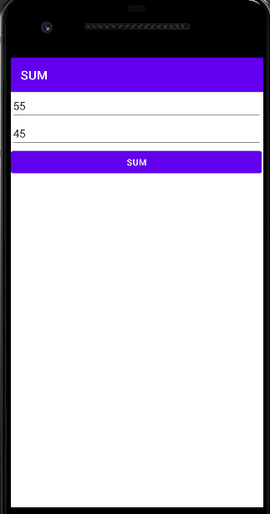

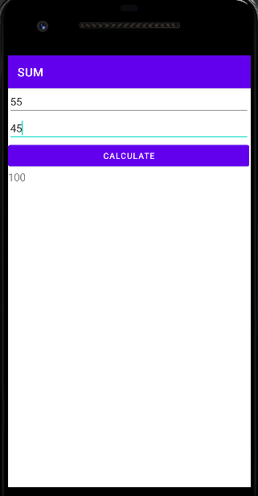

Demo Menu

Main

package com.example.menudemo;

import androidx.appcompat.app.AppCompatActivity;

import android.os.Bundle;

import android.view.Menu;

import android.view.MenuItem;

import android.widget.Toast;

public class MainActivity extends AppCompatActivity {

@Override

protected void onCreate(Bundle savedInstanceState) {

super.onCreate(savedInstanceState);

setContentView(R.layout.activity_main);

}

@Override

public boolean onCreateOptionsMenu(Menu m)

{

getMenuInflater().inflate(R.menu.menu, m);

return true;

}

public boolean onOptionsItemSelected(MenuItem mi)

{

if(mi.getTitle().toString().equals("Exit"))

{

finish();

}

else if(mi.getItemId()==R.id.new1)

{

Toast.makeText(this, "New Menu Clicked", Toast.LENGTH_SHORT).show();

}

else if(mi.getItemId() == R.id.help)

{

Toast.makeText(this, "Help Clicked", Toast.LENGTH_SHORT).show();

}

return true;

}

}

XML Main

<?xml version="1.0" encoding="utf-8"?>

<androidx.constraintlayout.widget.ConstraintLayout xmlns:android="http://schemas.android.com/apk/res/android"

xmlns:app="http://schemas.android.com/apk/res-auto"

xmlns:tools="http://schemas.android.com/tools"

android:layout_width="match_parent"

android:layout_height="match_parent"

tools:context=".MainActivity">

<TextView

android:layout_width="wrap_content"

android:layout_height="wrap_content"

android:text="Hello Akhil!"

app:layout_constraintBottom_toBottomOf="parent"

app:layout_constraintEnd_toEndOf="parent"

app:layout_constraintStart_toStartOf="parent"

app:layout_constraintTop_toTopOf="parent" />

</androidx.constraintlayout.widget.ConstraintLayout>

XML Menu

<?xml version="1.0" encoding="utf-8"?>

<menu xmlns:app="http://schemas.android.com/apk/res-auto"

xmlns:android="http://schemas.android.com/apk/res/android">

<item

android:id="@+id/new1"

android:title="New" />

<item

android:id="@+id/help"

android:title="Help" />

<item

android:id="@+id/exit"

android:title="Exit" />

</menu>

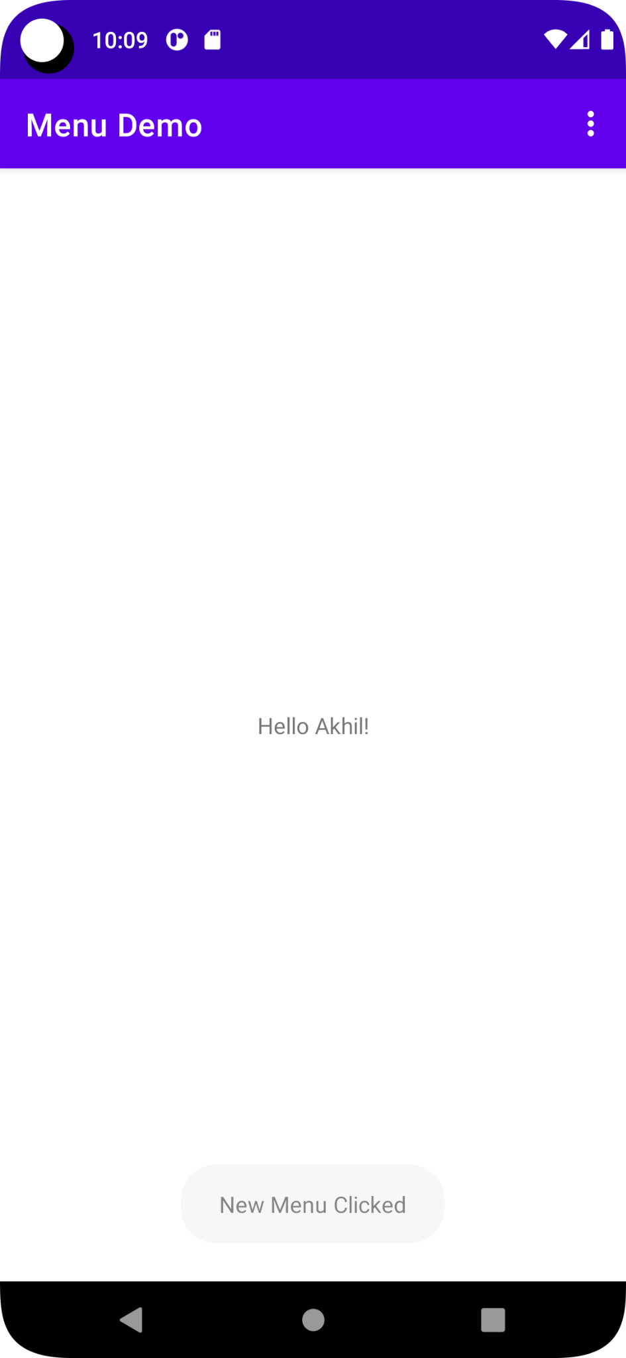

30/06/2022

**Activity_main.xml**

<?xml version="1.0" encoding="utf-8"?>

<androidx.constraintlayout.widget.ConstraintLayout xmlns:android="http://schemas.android.com/apk/res/android"

xmlns:app="http://schemas.android.com/apk/res-auto"

xmlns:tools="http://schemas.android.com/tools"

android:layout_width="match_parent"

android:layout_height="match_parent"

tools:context=".MainActivity">

<LinearLayout

android:layout_width="409dp"

android:layout_height="729dp"

android:orientation="vertical"

tools:layout_editor_absoluteX="1dp"

tools:layout_editor_absoluteY="1dp">

<EditText

android:id="@+id/et1"

android:layout_width="match_parent"

android:layout_height="wrap_content"

android:ems="10"

android:inputType="textPersonName"

android:text="" />

<Button

android:id="@+id/bright"

android:layout_width="match_parent"

android:layout_height="wrap_content"

android:text="Right Click" />

</LinearLayout>

</androidx.constraintlayout.widget.ConstraintLayout>

**Mainactivity.java**

package com.example.contextmenudemo;

import androidx.appcompat.app.AppCompatActivity;

import android.os.Bundle;

import android.view.ContextMenu;

import android.view.MenuItem;

import android.view.View;

import android.widget.Button;

import android.widget.EditText;

import android.widget.Toast;

public class MainActivity extends AppCompatActivity {

Button b1;

EditText e1;

@Override

protected void onCreate(Bundle savedInstanceState) {

super.onCreate(savedInstanceState);

setContentView(R.layout.activity_main);

b1=(Button) findViewById(R.id.bright);

e1=(EditText) findViewById(R.id.et1);

registerForContextMenu(b1);

}

@Override

public void onCreateContextMenu(ContextMenu menu, View v, ContextMenu.ContextMenuInfo menuInfo)

{

super.onCreateContextMenu(menu,v,menuInfo);

menu.setHeaderTitle("Select");

menu.add("call");

menu.add("SMS");

}

@Override

public boolean onContextItemSelected(MenuItem item)

{

if(item.getTitle().toString().equals("call"))

{

e1.setText("calling.........");

// Toast.makeText(this,"calling.........",Toast.LENGTH_SHORT).show();

}

else if(item.getTitle().toString().equals("SMS"))

{

e1.setText("sending.........");

Toast.makeText(this,"Sending..........",Toast.LENGTH_SHORT).show();

}

return super.onContextItemSelected(item);

}

}

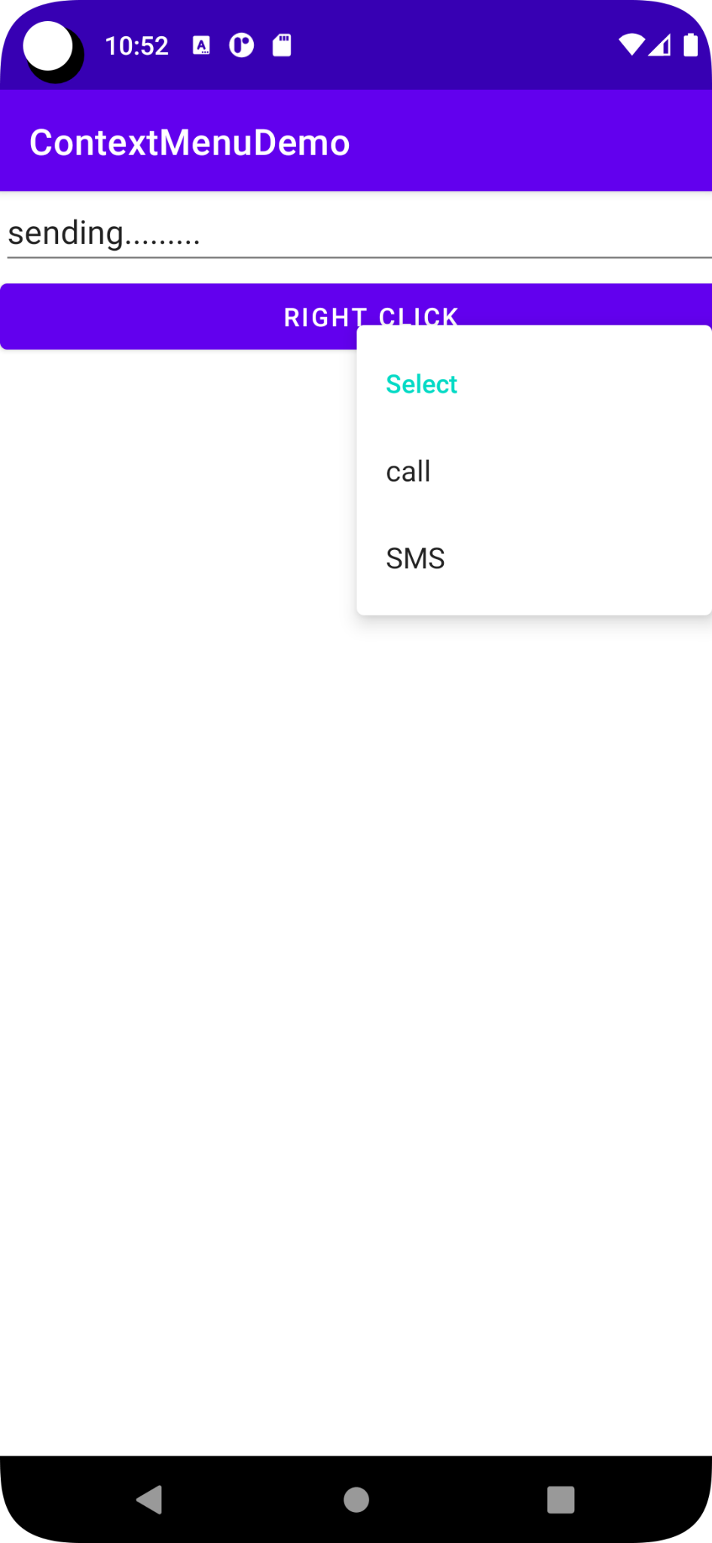

**Calling to a number**

**Activity_main.xml**

<?xml version="1.0" encoding="utf-8"?>

<androidx.constraintlayout.widget.ConstraintLayout xmlns:android="http://schemas.android.com/apk/res/android"

xmlns:app="http://schemas.android.com/apk/res-auto"

xmlns:tools="http://schemas.android.com/tools"

android:layout_width="match_parent"

android:layout_height="match_parent"

tools:context=".MainActivity">

<LinearLayout

android:layout_width="409dp"

android:layout_height="729dp"

android:orientation="vertical"

tools:layout_editor_absoluteX="1dp"

tools:layout_editor_absoluteY="1dp">

<EditText

android:id="@+id/et1"

android:layout_width="match_parent"

android:layout_height="wrap_content"

android:ems="10"

android:inputType="textPersonName"

android:text="" />

<Button

android:id="@+id/bcall"

android:layout_width="match_parent"

android:layout_height="wrap_content"

android:onClick="onCall"

android:text="Call" />

</LinearLayout>

</androidx.constraintlayout.widget.ConstraintLayout>

**MainActivity.java**

package com.example.calldemo;

import androidx.appcompat.app.AppCompatActivity;

import android.content.Intent;

import android.net.Uri;

import android.os.Bundle;

import android.view.View;

import android.widget.EditText;

public class MainActivity extends AppCompatActivity {

@Override

protected void onCreate(Bundle savedInstanceState) {

super.onCreate(savedInstanceState);

setContentView(R.layout.activity_main);

}

public void onCall(View v)

{

Intent callIntent=new Intent(Intent.ACTION_CALL);

EditText e1=(EditText) findViewById(R.id.et1);

callIntent.setData(Uri.parse("tel:"+e1.getText().toString()));

startActivity(callIntent);

}

}

**Androidmanifest.xml**

<?xml version="1.0" encoding="utf-8"?>

<manifest xmlns:android="http://schemas.android.com/apk/res/android"

xmlns:tools="http://schemas.android.com/tools"

package="com.example.calldemo">

<uses-permission android:name="android.permission.CALL_PHONE"/>

<application

android:allowBackup="true"

android:dataExtractionRules="@xml/data_extraction_rules"

android:fullBackupContent="@xml/backup_rules"

android:icon="@mipmap/ic_launcher"

android:label="@string/app_name"

android:roundIcon="@mipmap/ic_launcher_round"

android:supportsRtl="true"

android:theme="@style/Theme.CallDemo"

tools:targetApi="31">

<activity

android:name=".MainActivity"

android:exported="true">

<intent-filter>

<action android:name="android.intent.action.MAIN" />

<category android:name="android.intent.category.LAUNCHER" />

</intent-filter>

</activity>

</application>

</manifest>

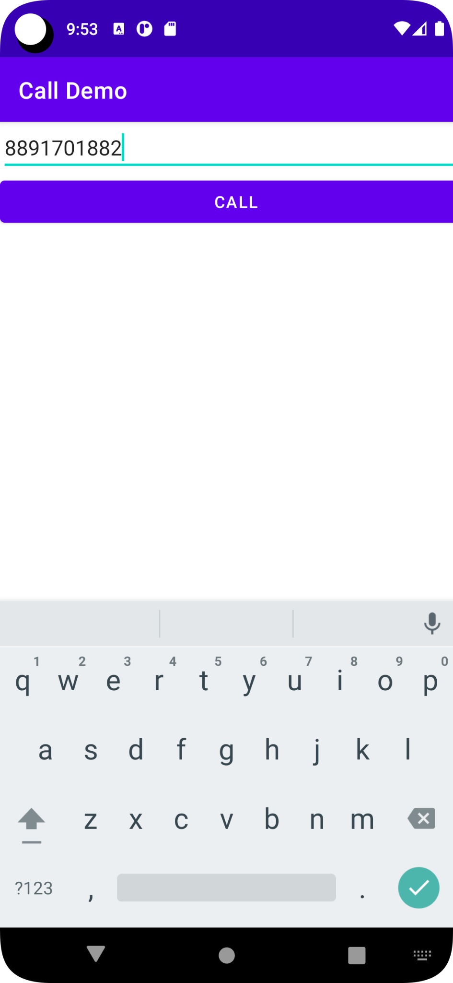

01/07/2022

App Life Cycle

Main

package rajagiri.alc;

import androidx.appcompat.app.AppCompatActivity;

import android.os.Bundle;

import android.util.Log;

public class MainActivity extends AppCompatActivity {

String msg = "Android: ";

@Override

protected void onCreate(Bundle savedInstanceState) {

super.onCreate(savedInstanceState);

setContentView(R.layout.activity_main);

}

@Override

protected void onStart() {

super.onStart();

Log.d(msg, "The onStart() event");

}

@Override

protected void onResume() {

super.onResume();

Log.d(msg, "The onResume() event");

}

@Override

protected void onPause() {

super.onPause();

Log.d(msg, "The onPause() event");

}

@Override

protected void onStop() {

super.onStop();

Log.d(msg, "The onStop() event");

}

@Override

public void onDestroy() {

super.onDestroy();

Log.d(msg, "The onDestroy() event");

}

}

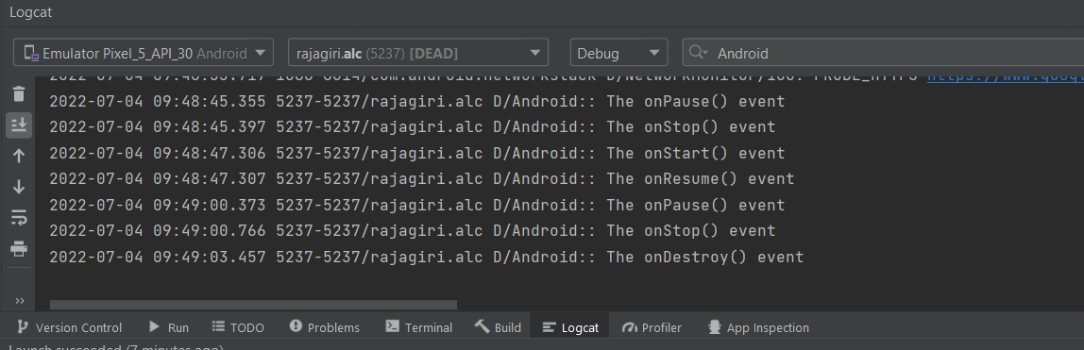

List View

Main

package com.example.listview_1;

import androidx.appcompat.app.AppCompatActivity;

import android.app.ListActivity;

import android.os.Bundle;

import android.view.View;

import android.widget.AdapterView;

import android.widget.ArrayAdapter;

import android.widget.ListView;

import android.widget.TextView;

import android.widget.Toast;

public class MainActivity extends AppCompatActivity implements AdapterView.OnItemClickListener {

static final String lst[] = new String[]{"One","Two","Three"};

ListView lv1;

@Override

protected void onCreate(Bundle savedInstanceState) {

super.onCreate(savedInstanceState);

setContentView(R.layout.activity_main);

lv1 = (ListView)findViewById(R.id.lv);

final ArrayAdapter<String>adapter = new ArrayAdapter<String>(this, android.R.layout.simple_list_item_1,android.R.id.text1,lst);

lv1.setAdapter(adapter);

lv1.setOnItemClickListener(this);

}

@Override

public void onItemClick(AdapterView<?> adapterView, View view, int i, long l) {

String s;

TextView tv = (TextView)view;

s=(String)tv.getText().toString();

Toast.makeText(this,s,Toast.LENGTH_SHORT).show();

}

}

XML

<?xml version="1.0" encoding="utf-8"?>

<androidx.constraintlayout.widget.ConstraintLayout xmlns:android="http://schemas.android.com/apk/res/android"

xmlns:app="http://schemas.android.com/apk/res-auto"

xmlns:tools="http://schemas.android.com/tools"

android:layout_width="match_parent"

android:layout_height="match_parent"

tools:context=".MainActivity">

<LinearLayout

android:layout_width="409dp"

android:layout_height="729dp"

android:orientation="vertical"

tools:layout_editor_absoluteX="1dp"

tools:layout_editor_absoluteY="1dp">

<ListView

android:id="@+id/lv"

android:layout_width="fill_parent"

android:layout_height="384dp" />

</LinearLayout>

</androidx.constraintlayout.widget.ConstraintLayout>

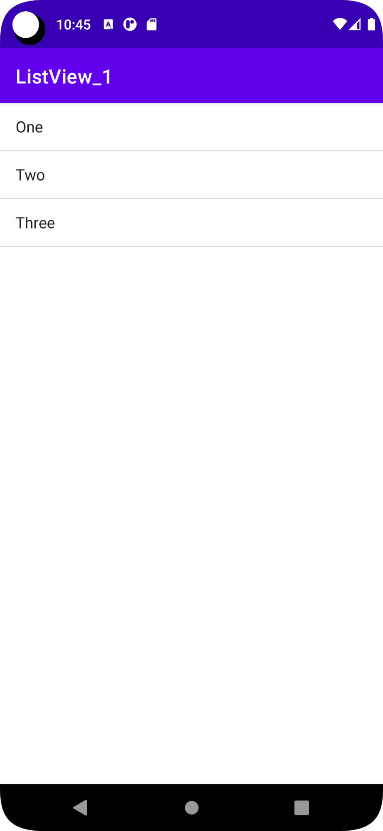

01/07/2022

Fragment Demo

Main Java

package com.example.fragdemo;

import androidx.appcompat.app.AppCompatActivity;

//import androidx.fragment.app.Fragment;

import android.app.Fragment;

import android.app.FragmentManager;

import android.app.FragmentTransaction;

import android.os.Bundle;

import android.view.View;

import android.widget.Button;

public class MainActivity extends AppCompatActivity {

Button ff,sf;

@Override

protected void onCreate(Bundle savedInstanceState) {

super.onCreate(savedInstanceState);

setContentView(R.layout.activity_main);

ff = (Button)findViewById(R.id.btn1);

sf = (Button)findViewById(R.id.btn2);

ff.setOnClickListener(new View.OnClickListener(){

@Override

public void onClick(View view){

loadFragment(new FirstFragment());

}

});

sf.setOnClickListener(new View.OnClickListener(){

@Override

public void onClick(View view){

loadFragment(new SecondFragment());

}

});

}

private void loadFragment(Fragment fragment)

{

FragmentManager fm = getFragmentManager();

FragmentTransaction fragmentTransaction = fm.beginTransaction();

fragmentTransaction.replace(R.id.frameLayout,fragment);

fragmentTransaction.commit();

}

}

Main XML

<?xml version="1.0" encoding="utf-8"?>

<androidx.constraintlayout.widget.ConstraintLayout xmlns:android="http://schemas.android.com/apk/res/android"

xmlns:app="http://schemas.android.com/apk/res-auto"

xmlns:tools="http://schemas.android.com/tools"

android:layout_width="match_parent"

android:layout_height="match_parent"

tools:context=".MainActivity">

<LinearLayout

android:layout_width="409dp"

android:layout_height="729dp"

android:orientation="vertical"

tools:layout_editor_absoluteX="1dp"

tools:layout_editor_absoluteY="1dp">

<Button

android:id="@+id/btn1"

android:layout_width="match_parent"

android:layout_height="wrap_content"

android:text="First Fragment" />

<Button

android:id="@+id/btn2"

android:layout_width="match_parent"

android:layout_height="wrap_content"

android:text="Second Fragment" />

<FrameLayout

android:id="@+id/frameLayout"

android:layout_width="match_parent"

android:layout_height="match_parent">

</FrameLayout>

</LinearLayout>

</androidx.constraintlayout.widget.ConstraintLayout>

FirstFragment JAVA

package com.example.fragdemo;

import android.os.Bundle;

import android.view.LayoutInflater;

import android.view.View;

import android.view.ViewGroup;

import android.widget.Button;

import android.widget.Toast;

import android.app.Fragment;

public class FirstFragment extends Fragment {

View v;

Button b1;

public View onCreateView(LayoutInflater inflater, ViewGroup container, Bundle savedInstanceState)

{

v = inflater.inflate(R.layout.fragment_first, container,false);

b1 = (Button)v.findViewById(R.id.b1);

b1.setOnClickListener(new View.OnClickListener() {

@Override

public void onClick(View view) {

Toast.makeText(getActivity(),"First Fragment", Toast.LENGTH_SHORT).show();

}

});

return v;

}

}

FirstFragment XML

<?xml version="1.0" encoding="utf-8"?>

<androidx.constraintlayout.widget.ConstraintLayout xmlns:android="http://schemas.android.com/apk/res/android"

xmlns:tools="http://schemas.android.com/tools"

android:layout_width="match_parent"

android:layout_height="match_parent"

tools:context="com.example.fragdemo.FirstFragment">

<LinearLayout

android:layout_width="409dp"

android:layout_height="729dp"

android:orientation="vertical"

tools:layout_editor_absoluteX="1dp"

tools:layout_editor_absoluteY="1dp">

<Button

android:id="@+id/b1"

android:layout_width="match_parent"

android:layout_height="wrap_content"

android:text="FIRST FRAGMENT" />

</LinearLayout>

</androidx.constraintlayout.widget.ConstraintLayout>

Second Fragment JAVA

package com.example.fragdemo;

import android.app.Fragment;

import android.os.Bundle;

import android.view.LayoutInflater;

import android.view.View;

import android.view.ViewGroup;

import android.widget.Button;

import android.widget.Toast;

public class SecondFragment extends Fragment {

View v;

Button b1;

public View onCreateView(LayoutInflater inflater, ViewGroup container, Bundle savedInstanceState)

{

v = inflater.inflate(R.layout.fragment_second, container,false);

b1 = (Button)v.findViewById(R.id.b2);

b1.setOnClickListener(new View.OnClickListener() {

@Override

public void onClick(View view) {

Toast.makeText(getActivity(),"Second Fragment", Toast.LENGTH_SHORT).show();

}

});

return v;

}

}

Second Fragment XML

<?xml version="1.0" encoding="utf-8"?>

<androidx.constraintlayout.widget.ConstraintLayout xmlns:android="http://schemas.android.com/apk/res/android"

xmlns:tools="http://schemas.android.com/tools"

android:layout_width="match_parent"

android:layout_height="match_parent"

tools:context="com.example.fragdemo.SecondFragment">

<LinearLayout

android:layout_width="409dp"

android:layout_height="889dp"

android:orientation="vertical"

tools:layout_editor_absoluteX="1dp"

tools:layout_editor_absoluteY="1dp">

<Button

android:id="@+id/b2"

android:layout_width="match_parent"

android:layout_height="wrap_content"

android:text="Second Fragment" />

</LinearLayout>

</androidx.constraintlayout.widget.ConstraintLayout>

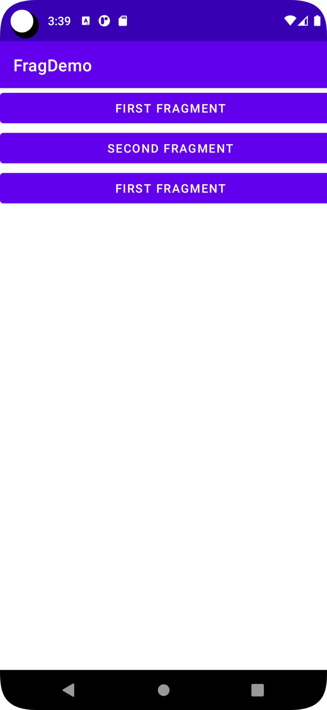

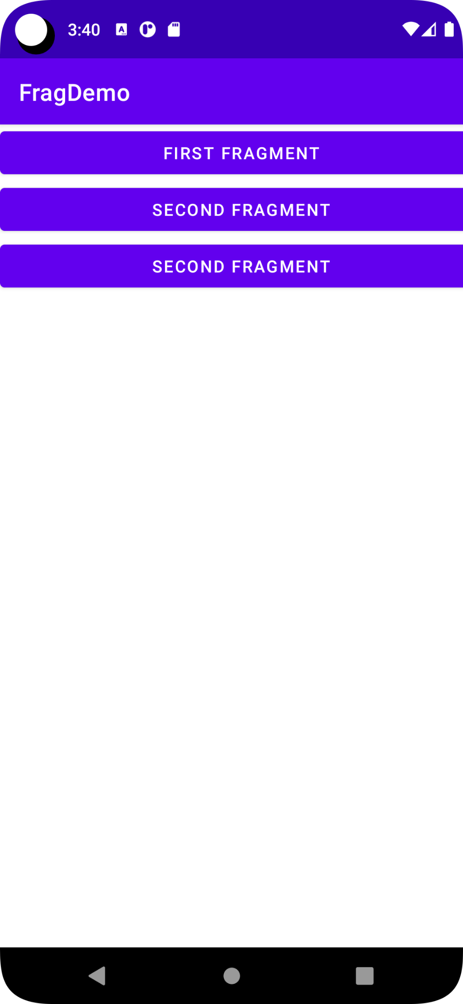

11/07/2022

Web search

Main

package com.example.browsewttext;

import androidx.appcompat.app.AppCompatActivity;

import android.content.Intent;

import android.net.Uri;

import android.os.Bundle;

import android.view.View;

import android.widget.EditText;

public class MainActivity extends AppCompatActivity {

@Override

protected void onCreate(Bundle savedInstanceState) {

super.onCreate(savedInstanceState);

setContentView(R.layout.activity_main);

}

public void onGo(View v)

{

EditText e = (EditText)findViewById(R.id.et1);

Intent i = new Intent(Intent.ACTION_VIEW);

i.setData(Uri.parse("https://google.com/search?q="+e.getText().toString()));

startActivity(i);

}

}

Main XML

<?xml version="1.0" encoding="utf-8"?>

<androidx.constraintlayout.widget.ConstraintLayout xmlns:android="http://schemas.android.com/apk/res/android"

xmlns:app="http://schemas.android.com/apk/res-auto"

xmlns:tools="http://schemas.android.com/tools"

android:layout_width="match_parent"

android:layout_height="match_parent"

tools:context=".MainActivity">

<LinearLayout

android:layout_width="409dp"

android:layout_height="729dp"

android:orientation="vertical"

tools:layout_editor_absoluteX="1dp"

tools:layout_editor_absoluteY="1dp">

<EditText

android:id="@+id/et1"

android:layout_width="match_parent"

android:layout_height="wrap_content"

android:ems="10"

android:hint="Enter keyword to search"

android:inputType="textPersonName" />

<Button

android:id="@+id/btn1"

android:layout_width="match_parent"

android:layout_height="wrap_content"

android:onClick="onGo"

android:text="Google" />

</LinearLayout>

</androidx.constraintlayout.widget.ConstraintLayout>

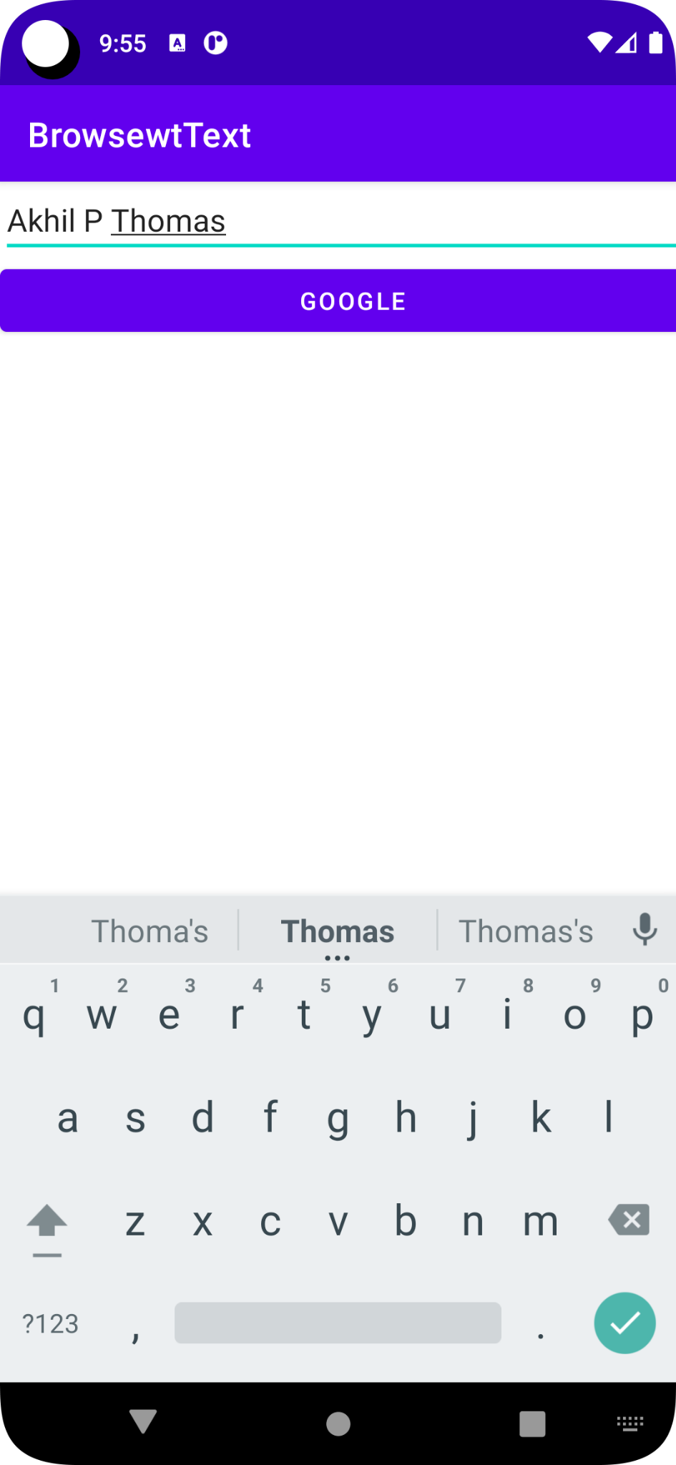



Q) Search in different search engine.

Main

package com.example.browsediffengin;

import androidx.appcompat.app.AppCompatActivity;

import android.content.Intent;

import android.net.Uri;

import android.os.Bundle;

import android.view.View;

import android.widget.EditText;

import android.widget.RadioButton;

public class MainActivity extends AppCompatActivity {

RadioButton rb1,rb2,rb3;

@Override

protected void onCreate(Bundle savedInstanceState) {

super.onCreate(savedInstanceState);

setContentView(R.layout.activity_main);

}

public void onSearch(View v)

{

rb1 = (RadioButton)findViewById(R.id.rb1);

rb2 = (RadioButton)findViewById(R.id.rb2);

rb3 = (RadioButton)findViewById(R.id.rb3);

EditText e = (EditText)findViewById(R.id.et1);

Intent i = new Intent(Intent.ACTION_VIEW);

if(rb1.isChecked())

{

i.setData(Uri.parse("https://google.com/search?q="+e.getText().toString()));

startActivity(i);

}

else if(rb2.isChecked())

{

i.setData(Uri.parse("https://www.bing.com/search?q="+e.getText().toString()));

startActivity(i);

}

else if(rb3.isChecked())

{

i.setData(Uri.parse("https://yandex.com/search/?text="+e.getText().toString()));

startActivity(i);

}

}

}

Main XML

<?xml version="1.0" encoding="utf-8"?>

<androidx.constraintlayout.widget.ConstraintLayout xmlns:android="http://schemas.android.com/apk/res/android"

xmlns:app="http://schemas.android.com/apk/res-auto"

xmlns:tools="http://schemas.android.com/tools"

android:layout_width="match_parent"

android:layout_height="match_parent"

tools:context=".MainActivity">

<LinearLayout

android:layout_width="409dp"

android:layout_height="729dp"

android:orientation="vertical"

tools:layout_editor_absoluteX="1dp"

tools:layout_editor_absoluteY="1dp">

<RadioGroup

android:layout_width="match_parent"

android:layout_height="159dp">

<RadioButton

android:id="@+id/rb1"

android:layout_width="match_parent"

android:layout_height="wrap_content"

android:checked="true"

android:text="Google" />

<RadioButton

android:id="@+id/rb2"

android:layout_width="match_parent"

android:layout_height="wrap_content"

android:text="Bing" />

<RadioButton

android:id="@+id/rb3"

android:layout_width="match_parent"

android:layout_height="wrap_content"

android:text="Yandex" />

</RadioGroup>

<EditText

android:id="@+id/et1"

android:layout_width="match_parent"

android:layout_height="wrap_content"

android:ems="10"

android:hint="Enter keyword to search"

android:inputType="textPersonName" />

<Button

android:id="@+id/bt1"

android:layout_width="match_parent"

android:layout_height="wrap_content"

android:onClick="onSearch"

android:text="Search" />

</LinearLayout>

</androidx.constraintlayout.widget.ConstraintLayout>

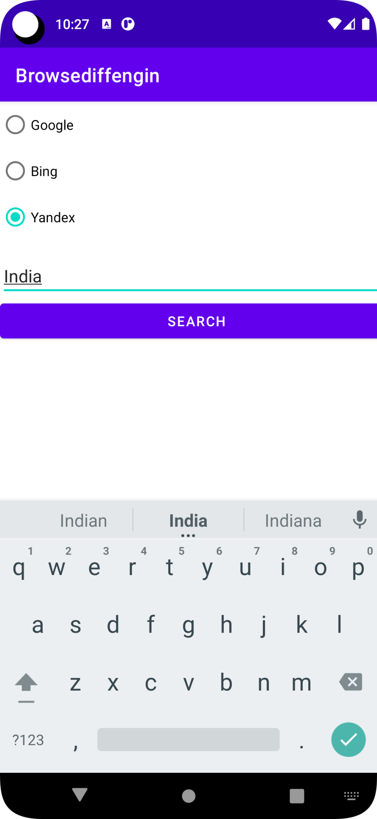

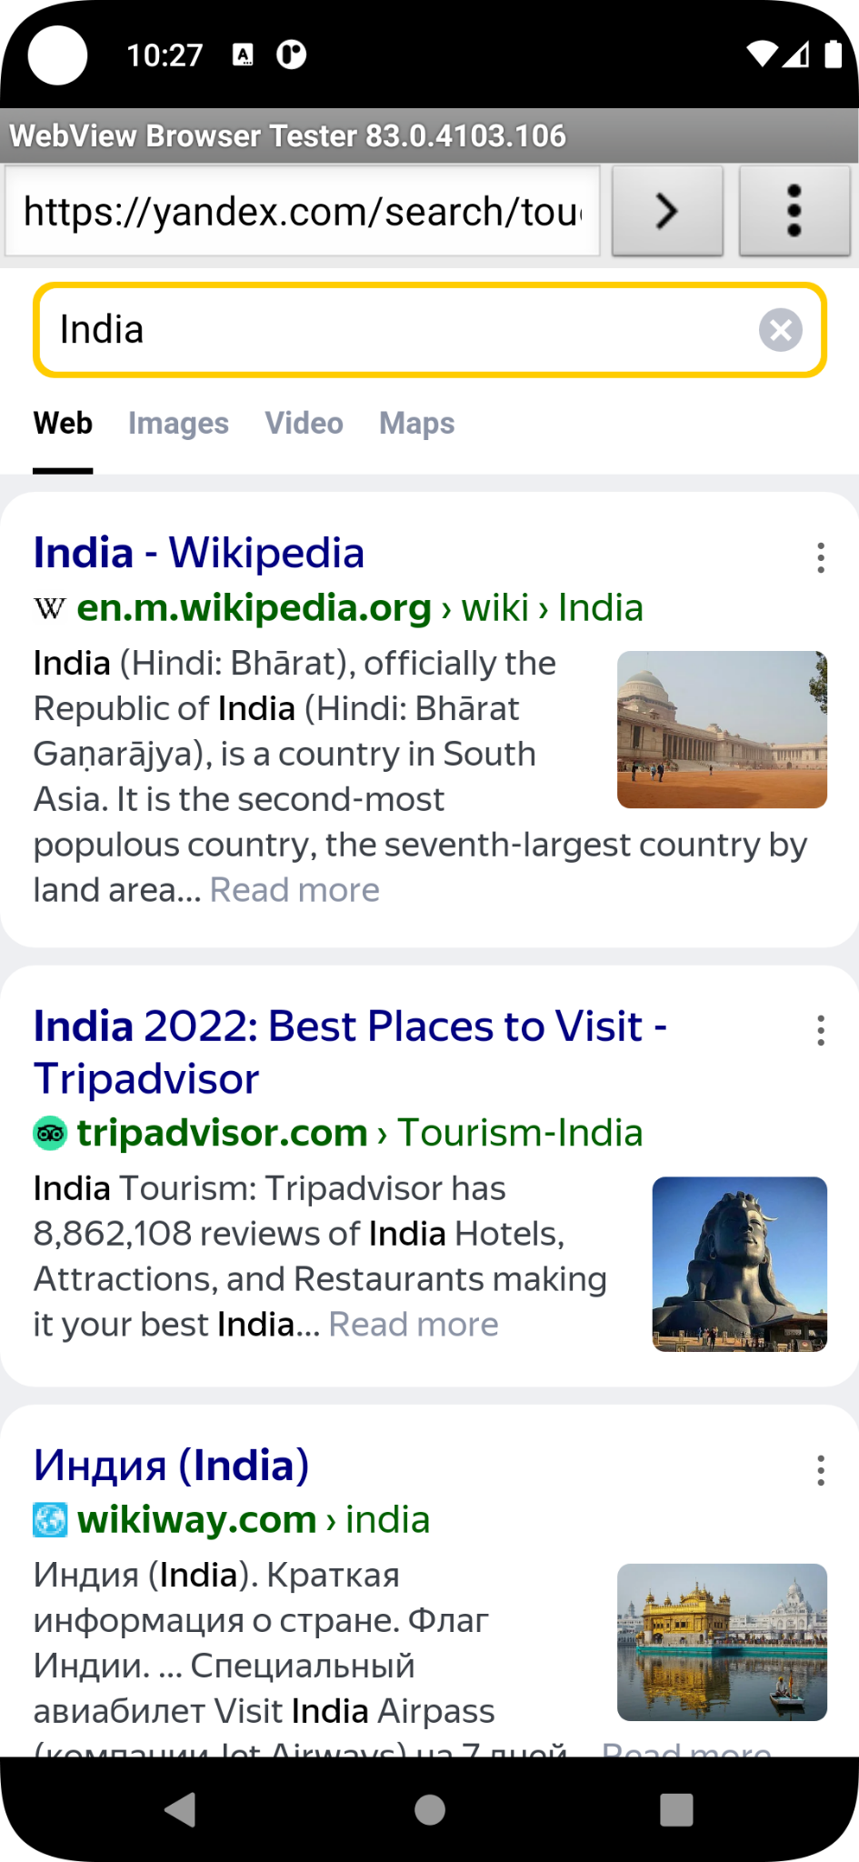

25/07/2022

Q) Shared Preferences on multiple page.

Main java

package com.example.spdemo;

import androidx.appcompat.app.AppCompatActivity;

import android.content.Context;

import android.content.Intent;

import android.content.SharedPreferences;

import android.os.Bundle;

import android.view.View;

import android.widget.EditText;

import android.widget.ShareActionProvider;

public class MainActivity extends AppCompatActivity {

EditText ed1,ed2;

@Override

protected void onCreate(Bundle savedInstanceState) {

super.onCreate(savedInstanceState);

setContentView(R.layout.activity_main);

}

public void onLogin(View v)

{

ed1 = (EditText) findViewById(R.id.e1);

ed2 = (EditText) findViewById(R.id.e2);

SharedPreferences sp = getSharedPreferences("SD", Context.MODE_PRIVATE);

SharedPreferences.Editor ed = sp.edit();

ed.putString("un", ed1.getText().toString());

ed.putString("up", ed2.getText().toString());

ed.commit();

Intent i = new Intent(this, SecActivity.class);

startActivity(i);

}

}

Main XML

<?xml version="1.0" encoding="utf-8"?>

<androidx.constraintlayout.widget.ConstraintLayout xmlns:android="http://schemas.android.com/apk/res/android"

xmlns:app="http://schemas.android.com/apk/res-auto"

xmlns:tools="http://schemas.android.com/tools"

android:layout_width="match_parent"

android:layout_height="match_parent"

tools:context=".MainActivity">

<LinearLayout

android:layout_width="409dp"

android:layout_height="729dp"

android:orientation="vertical"

tools:layout_editor_absoluteX="1dp"

tools:layout_editor_absoluteY="1dp">

<EditText

android:id="@+id/e1"

android:layout_width="match_parent"

android:layout_height="wrap_content"

android:ems="10"

android:inputType="textPersonName" />

<EditText

android:id="@+id/e2"

android:layout_width="match_parent"

android:layout_height="wrap_content"

android:ems="10"

android:inputType="textPersonName" />

<Button

android:id="@+id/bLogin"

android:layout_width="match_parent"

android:layout_height="wrap_content"

android:onClick="onLogin"

android:text="Login" />

</LinearLayout>

</androidx.constraintlayout.widget.ConstraintLayout>

SecActivity Java

package com.example.spdemo;

import android.content.Context;

import android.content.SharedPreferences;

import android.os.Bundle;

import android.view.View;

import android.widget.EditText;

import androidx.appcompat.app.AppCompatActivity;

public class SecActivity extends AppCompatActivity {

EditText ed11,ed22;

SharedPreferences sp;

@Override

protected void onCreate(Bundle savedInstanceState) {

super.onCreate(savedInstanceState);

setContentView(R.layout.activity_sec);

ed11 = (EditText) findViewById(R.id.e11);

ed22 = (EditText) findViewById(R.id.e22);

sp = getSharedPreferences("SD", Context.MODE_PRIVATE);

ed11.setText(sp.getString("un",""));

ed22.setText(sp.getString("up",""));

}

public void onClose(View v)

{

finish();

}

}

Sec XML

<?xml version="1.0" encoding="utf-8"?>

<androidx.constraintlayout.widget.ConstraintLayout xmlns:android="http://schemas.android.com/apk/res/android"

xmlns:app="http://schemas.android.com/apk/res-auto"

xmlns:tools="http://schemas.android.com/tools"

android:layout_width="match_parent"

android:layout_height="match_parent"

tools:context=".MainActivity">

<LinearLayout

android:layout_width="409dp"

android:layout_height="729dp"

android:orientation="vertical"

tools:layout_editor_absoluteX="1dp"

tools:layout_editor_absoluteY="1dp">

<EditText

android:id="@+id/e11"

android:layout_width="match_parent"

android:layout_height="wrap_content"

android:ems="10"

android:inputType="textPersonName" />

<EditText

android:id="@+id/e22"

android:layout_width="match_parent"

android:layout_height="wrap_content"

android:ems="10"

android:inputType="textPersonName" />

<Button

android:id="@+id/bClose"

android:layout_width="match_parent"

android:layout_height="wrap_content"

android:onClick="onClose"

android:text="CLOSE" />

</LinearLayout>

</androidx.constraintlayout.widget.ConstraintLayout>

Manifest

<?xml version="1.0" encoding="utf-8"?>

<manifest xmlns:android="http://schemas.android.com/apk/res/android"

xmlns:tools="http://schemas.android.com/tools"

package="com.example.spdemo">

<application

android:allowBackup="true"

android:dataExtractionRules="@xml/data_extraction_rules"

android:fullBackupContent="@xml/backup_rules"

android:icon="@mipmap/ic_launcher"

android:label="@string/app_name"

android:roundIcon="@mipmap/ic_launcher_round"

android:supportsRtl="true"

android:theme="@style/Theme.SPDemo"

tools:targetApi="31">

<activity

android:name=".MainActivity"

android:exported="true">

<intent-filter>

<action android:name="android.intent.action.MAIN" />

<category android:name="android.intent.category.LAUNCHER" />

</intent-filter>

</activity>

<activity

android:name=".SecActivity"

android:exported="true">

<intent-filter>

<action android:name="android.intent.action.Sec" />

<category android:name="android.intent.category.DEFAULT" />

</intent-filter>

</activity>

</application>

</manifest>

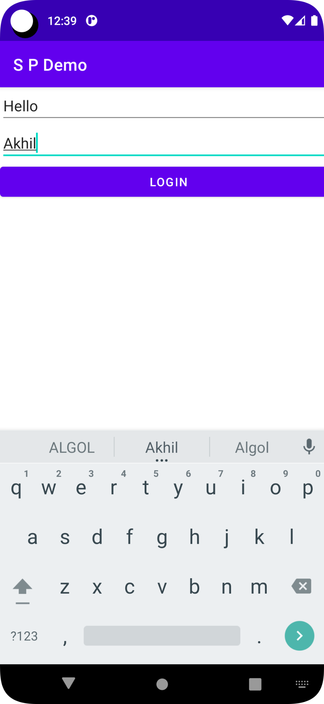

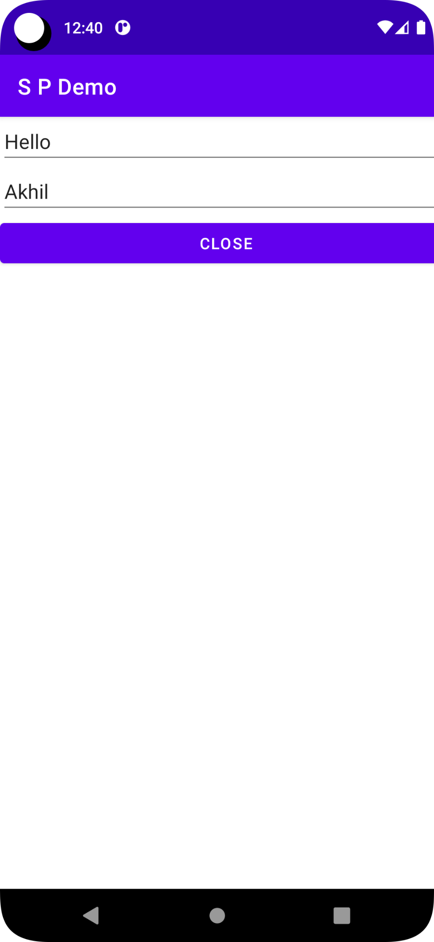

Q) Home page to 3ed page

Main java

package rajagiri.sphome;

import androidx.appcompat.app.AppCompatActivity;

import android.content.Context;

import android.content.Intent;

import android.content.SharedPreferences;

import android.os.Bundle;

import android.view.View;

import android.widget.EditText;

public class MainActivity extends AppCompatActivity {

EditText ed1;

@Override

protected void onCreate(Bundle savedInstanceState) {

super.onCreate(savedInstanceState);

setContentView(R.layout.activity_main);

}

public void onHome(View v)

{

ed1 = (EditText) findViewById(R.id.edt1);

SharedPreferences sp = getSharedPreferences("HP", Context.MODE_PRIVATE);

SharedPreferences.Editor ed = sp.edit();

ed.putString("h",ed1.getText().toString());

ed.commit();

Intent i = new Intent(this, SecActivity.class);

startActivity(i);

}

}

Main XML

<?xml version="1.0" encoding="utf-8"?>

<androidx.constraintlayout.widget.ConstraintLayout xmlns:android="http://schemas.android.com/apk/res/android"

xmlns:app="http://schemas.android.com/apk/res-auto"

xmlns:tools="http://schemas.android.com/tools"

android:layout_width="match_parent"

android:layout_height="match_parent"

tools:context=".MainActivity">

<LinearLayout

android:layout_width="409dp"

android:layout_height="729dp"

android:orientation="vertical"

tools:layout_editor_absoluteX="1dp"

tools:layout_editor_absoluteY="1dp">

<EditText

android:id="@+id/edt1"

android:layout_width="match_parent"

android:layout_height="wrap_content"

android:ems="10"

android:inputType="textPersonName" />

<Button

android:id="@+id/bHome"

android:layout_width="match_parent"

android:layout_height="wrap_content"

android:onClick="onHome"

android:text="Home" />

</LinearLayout>

</androidx.constraintlayout.widget.ConstraintLayout>

Sec Java

package rajagiri.sphome;

import androidx.appcompat.app.AppCompatActivity;

import android.content.Context;

import android.content.Intent;

import android.content.SharedPreferences;

import android.os.Bundle;

import android.view.View;

import android.widget.EditText;

import android.os.Bundle;

public class SecActivity extends AppCompatActivity {

@Override

protected void onCreate(Bundle savedInstanceState) {

super.onCreate(savedInstanceState);

setContentView(R.layout.activity_sec);

}

public void onShow(View v)

{

Intent i1 = new Intent(this, ThiActivity.class);

startActivity(i1);

}

}

Sec XML

<?xml version="1.0" encoding="utf-8"?>

<androidx.constraintlayout.widget.ConstraintLayout xmlns:android="http://schemas.android.com/apk/res/android"

xmlns:tools="http://schemas.android.com/tools"

android:layout_width="match_parent"

android:layout_height="match_parent">

<LinearLayout

android:layout_width="409dp"

android:layout_height="729dp"

android:orientation="vertical"

tools:layout_editor_absoluteX="1dp"

tools:layout_editor_absoluteY="1dp">

<Button

android:id="@+id/bShow"

android:layout_width="match_parent"

android:layout_height="wrap_content"

android:onClick="onShow"

android:text="Show" />

</LinearLayout>

</androidx.constraintlayout.widget.ConstraintLayout>

Thi Java

package rajagiri.sphome;

import android.content.Context;

import android.content.Intent;

import android.content.SharedPreferences;

import android.os.Bundle;

import android.view.View;

import android.widget.TextView;

import androidx.appcompat.app.AppCompatActivity;

public class ThiActivity extends AppCompatActivity {

@Override

protected void onCreate(Bundle savedInstanceState) {

super.onCreate(savedInstanceState);

setContentView(R.layout.activity_thi);

TextView tv1 = (TextView) findViewById(R.id.tv1);

SharedPreferences sp = getSharedPreferences("HP", Context.MODE_PRIVATE);

tv1.setText(sp.getString("h",""));

}

}

Thi XML

<?xml version="1.0" encoding="utf-8"?>

<androidx.constraintlayout.widget.ConstraintLayout xmlns:android="http://schemas.android.com/apk/res/android"

xmlns:tools="http://schemas.android.com/tools"

android:layout_width="match_parent"

android:layout_height="match_parent">

<LinearLayout

android:layout_width="409dp"

android:layout_height="729dp"

android:orientation="vertical"

tools:layout_editor_absoluteX="1dp"

tools:layout_editor_absoluteY="1dp">

<TextView

android:id="@+id/tv1"

android:layout_width="match_parent"

android:layout_height="wrap_content"

android:textSize="20sp" />

</LinearLayout>

</androidx.constraintlayout.widget.ConstraintLayout>

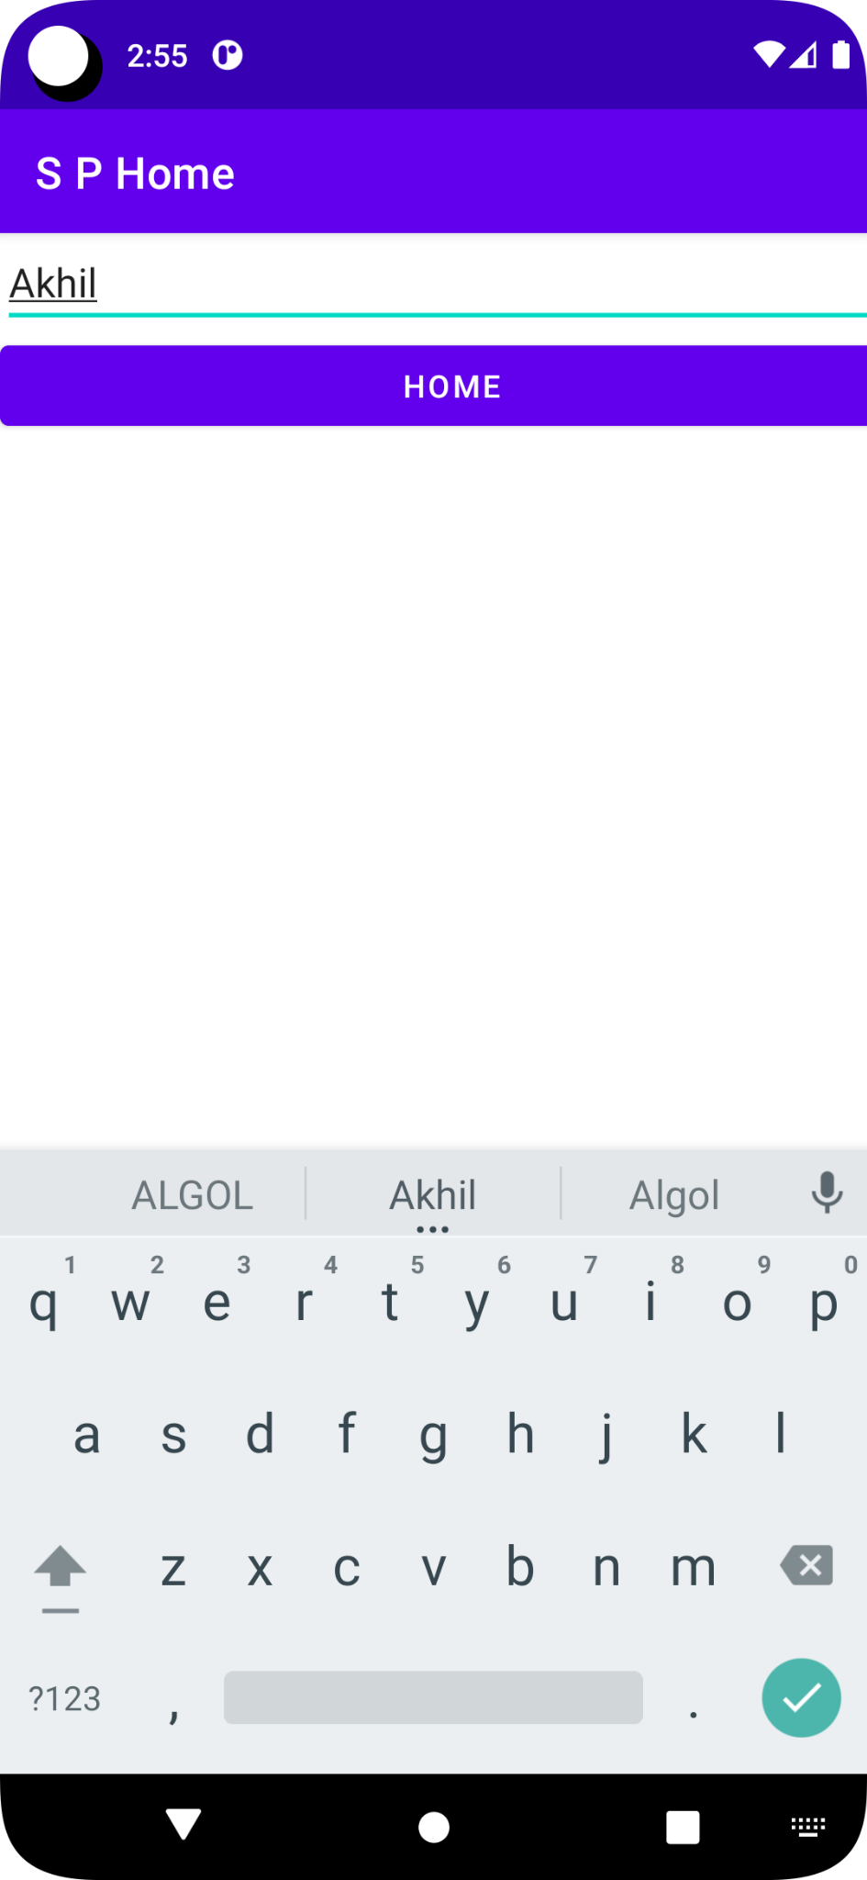

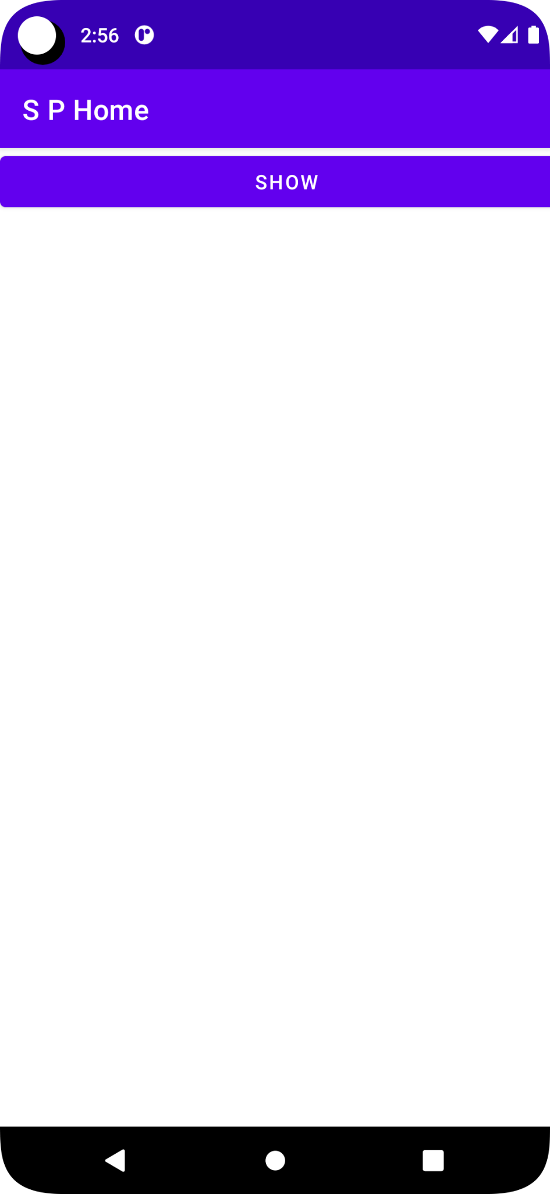

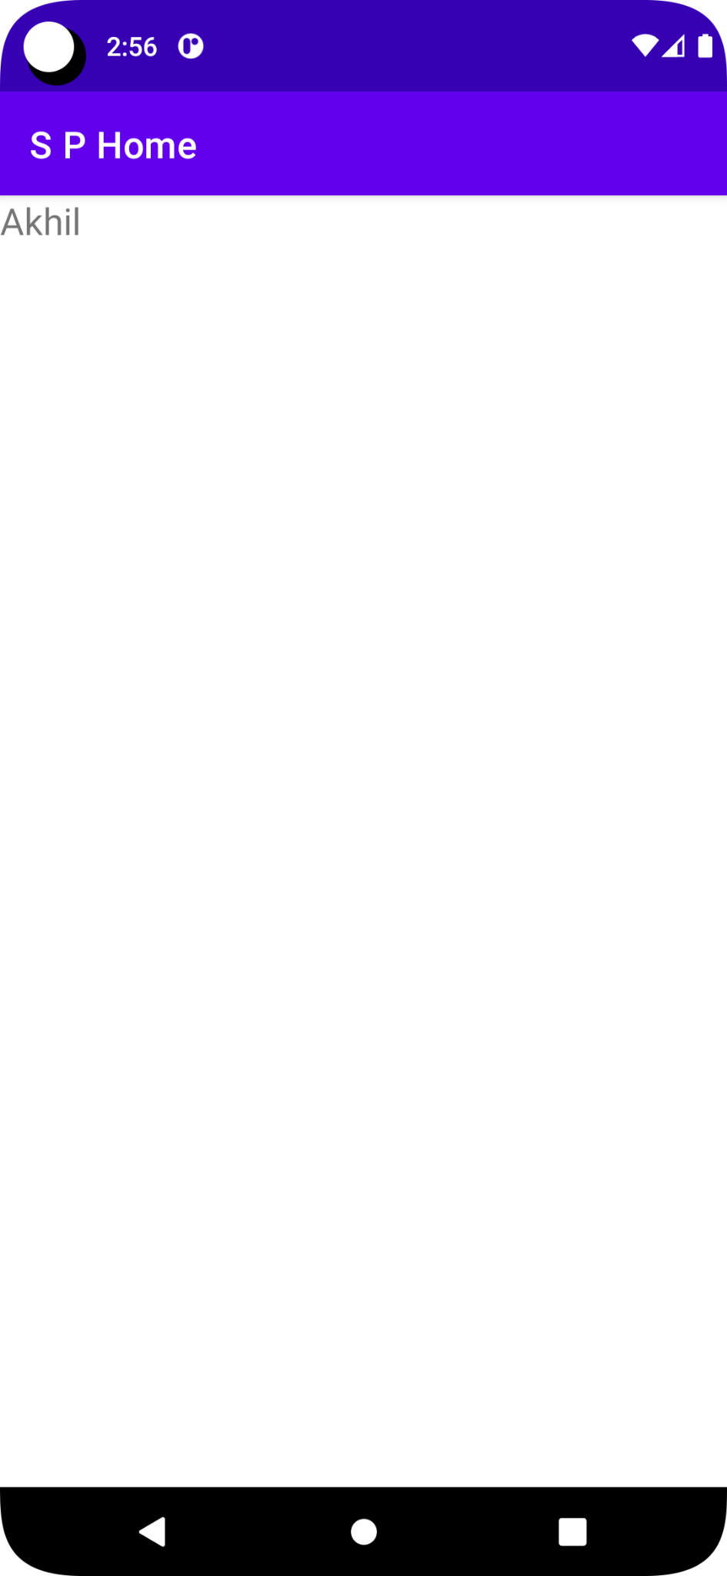

Q) File create write and read

Main Java

package com.example.filewriteread;

import androidx.appcompat.app.AppCompatActivity;

import android.content.SharedPreferences;

import android.os.Bundle;

import android.view.View;

import android.widget.EditText;

import android.widget.TextView;

import java.io.FileInputStream;

import java.io.FileNotFoundException;

import java.io.FileOutputStream;

import java.io.IOException;

import java.io.InputStreamReader;

import java.io.OutputStream;

import java.io.OutputStreamWriter;

public class MainActivity extends AppCompatActivity {

EditText et1,et2,et3;

@Override

protected void onCreate(Bundle savedInstanceState) {

super.onCreate(savedInstanceState);

setContentView(R.layout.activity_main);

et1= (EditText) findViewById(R.id.et1);

et2 = (EditText) findViewById(R.id.et2);

et3 = (EditText) findViewById(R.id.et3);

}

public void onSave(View v) throws IOException {

FileOutputStream fot = openFileOutput(et1.getText().toString(),0);

OutputStreamWriter osw = new OutputStreamWriter(fot);

osw.write(et2.getText().toString());

osw.flush();

osw.close();

fot.close();

}

public void onRead(View view) throws IOException {

FileInputStream fis = openFileInput(et3.getText().toString());

InputStreamReader isr = new InputStreamReader(fis);

char[] b = new char[50];

int n = isr.read(b,0,20);

String str = new String(b,0,n);

TextView tv1 = (TextView) findViewById(R.id.tv1);

tv1.setText(str);

isr.close();

fis.close();

}

}

Main XML

<?xml version="1.0" encoding="utf-8"?>

<androidx.constraintlayout.widget.ConstraintLayout xmlns:android="http://schemas.android.com/apk/res/android"

xmlns:app="http://schemas.android.com/apk/res-auto"

xmlns:tools="http://schemas.android.com/tools"

android:layout_width="match_parent"

android:layout_height="match_parent"

tools:context=".MainActivity">

<LinearLayout

android:layout_width="409dp"

android:layout_height="729dp"

android:orientation="vertical"

tools:layout_editor_absoluteX="1dp"

tools:layout_editor_absoluteY="1dp">

<EditText

android:id="@+id/et1"

android:layout_width="match_parent"

android:layout_height="wrap_content"

android:ems="10"

android:inputType="textPersonName" />

<EditText

android:id="@+id/et2"

android:layout_width="match_parent"

android:layout_height="wrap_content"

android:ems="10"

android:inputType="textPersonName" />

<Button

android:id="@+id/bSave"

android:layout_width="match_parent"

android:layout_height="wrap_content"

android:onClick="onSave"

android:text="Save" />

<EditText

android:id="@+id/et3"

android:layout_width="match_parent"

android:layout_height="wrap_content"

android:ems="10"

android:inputType="textPersonName" />

<Button

android:id="@+id/bRead"

android:layout_width="match_parent"

android:layout_height="wrap_content"

android:onClick="onRead"

android:text="Read" />

<TextView

android:id="@+id/tv1"

android:layout_width="match_parent"

android:layout_height="wrap_content"

android:textSize="20sp" />

</LinearLayout>

</androidx.constraintlayout.widget.ConstraintLayout>

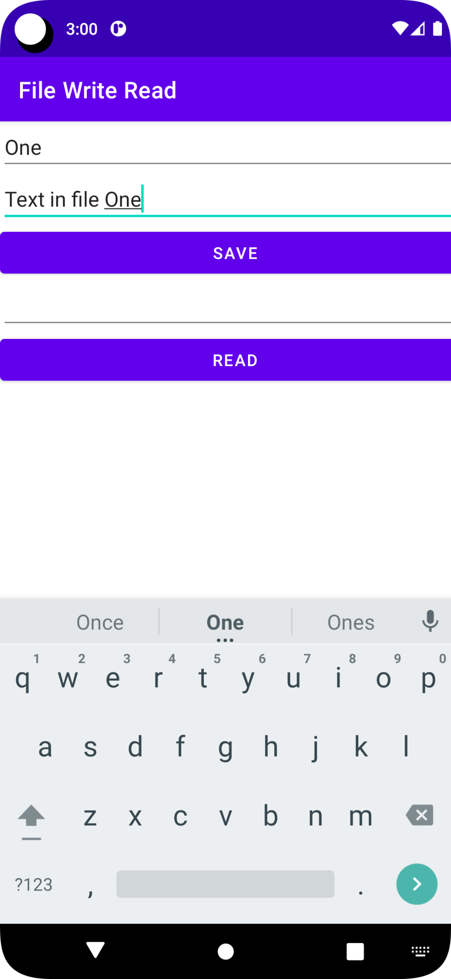

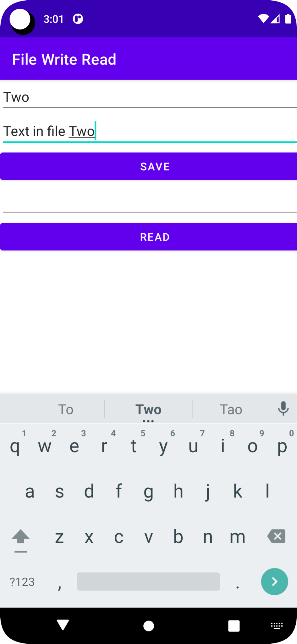

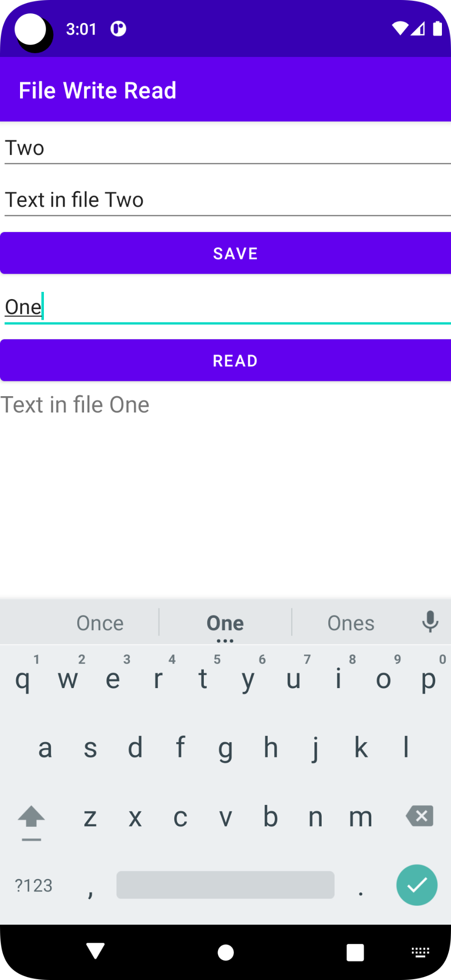

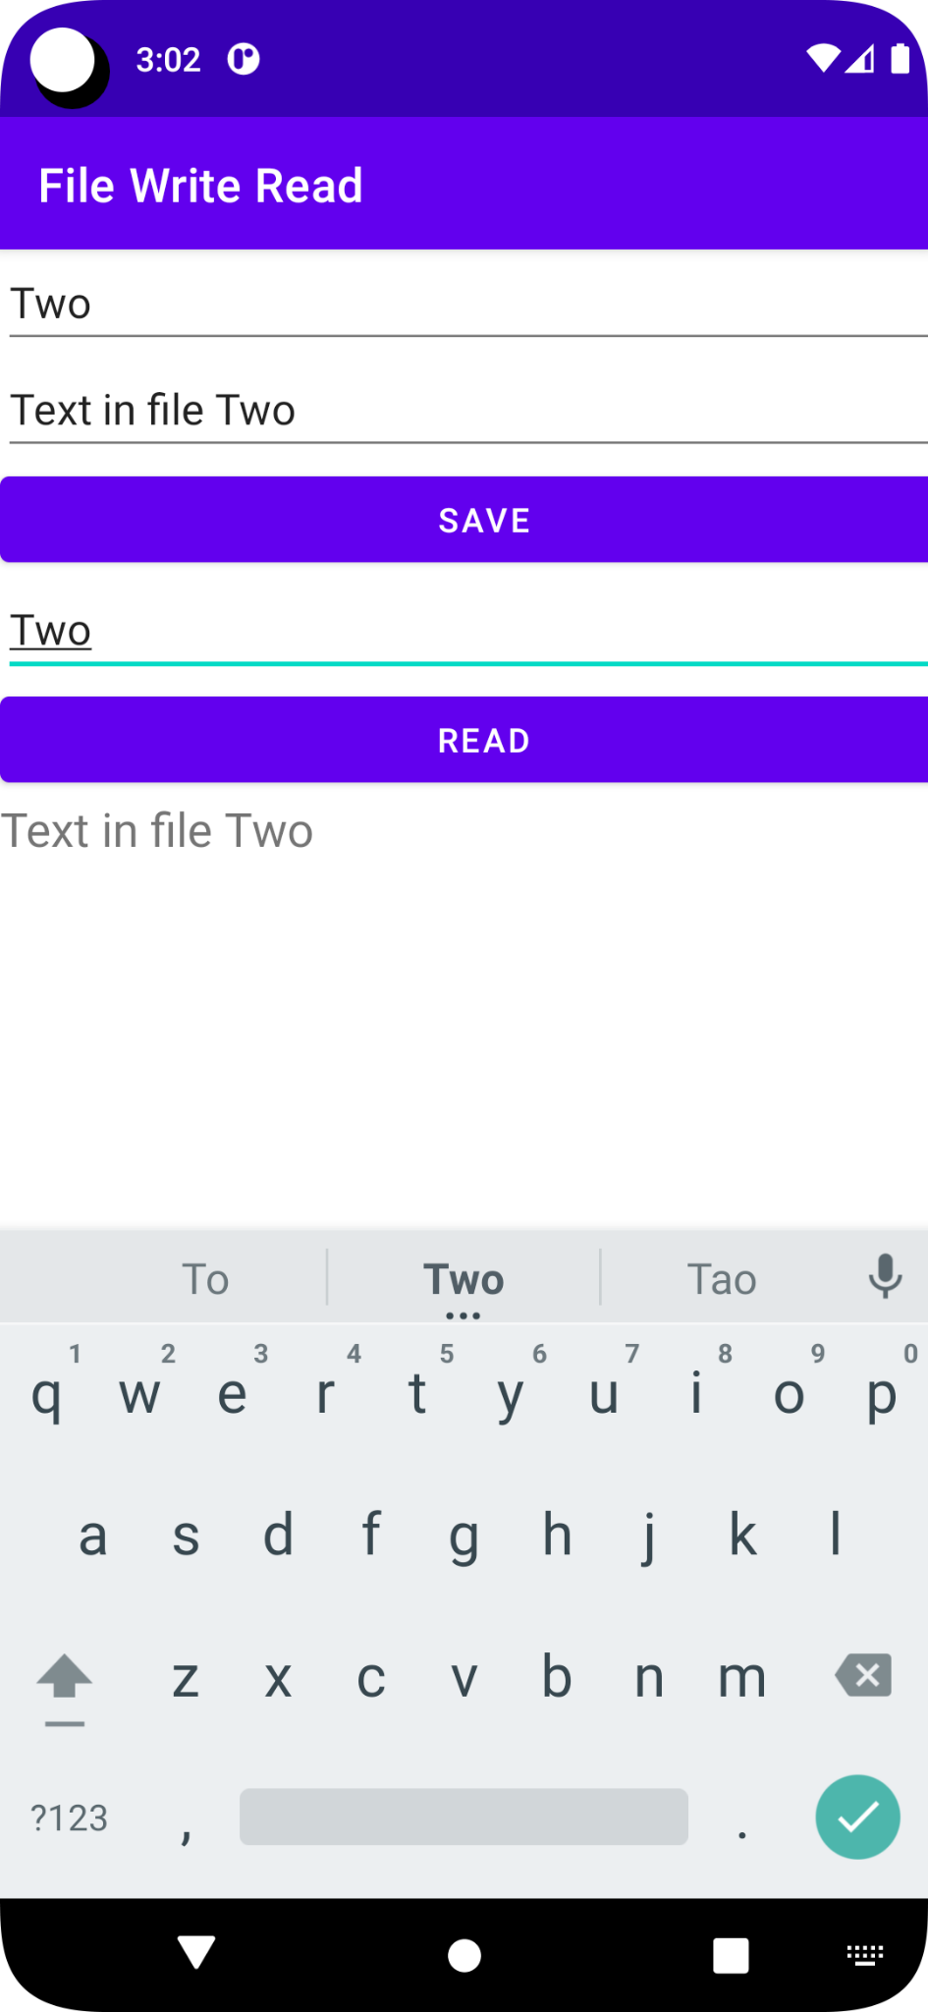

06/08/2022

Main Java

package com.example.threaddemo;

import androidx.appcompat.app.AppCompatActivity;

import android.os.Bundle;

import android.widget.Toast;

import java.util.concurrent.ExecutorService;

import java.util.concurrent.Executors;

public class MainActivity extends AppCompatActivity implements Runnable{

@Override

protected void onCreate(Bundle savedInstanceState) {

super.onCreate(savedInstanceState);

setContentView(R.layout.activity_main);

ExecutorService taskList = Executors.newFixedThreadPool(50);

taskList.execute(this);

}

public void run()

{

try{

for(int i=0; i<50; i++)

{

String tName = Thread.currentThread().getName();

System.out.println("Thread: "+tName+i);

try{

Thread.sleep(1000);

}

catch (Exception ex)

{

Toast.makeText(getApplicationContext(), ex.toString(),Toast.LENGTH_LONG).show();

}

}

}

catch (Exception ex)

{

Toast.makeText(getApplicationContext(), ex.toString(),Toast.LENGTH_LONG).show();

}

}

}

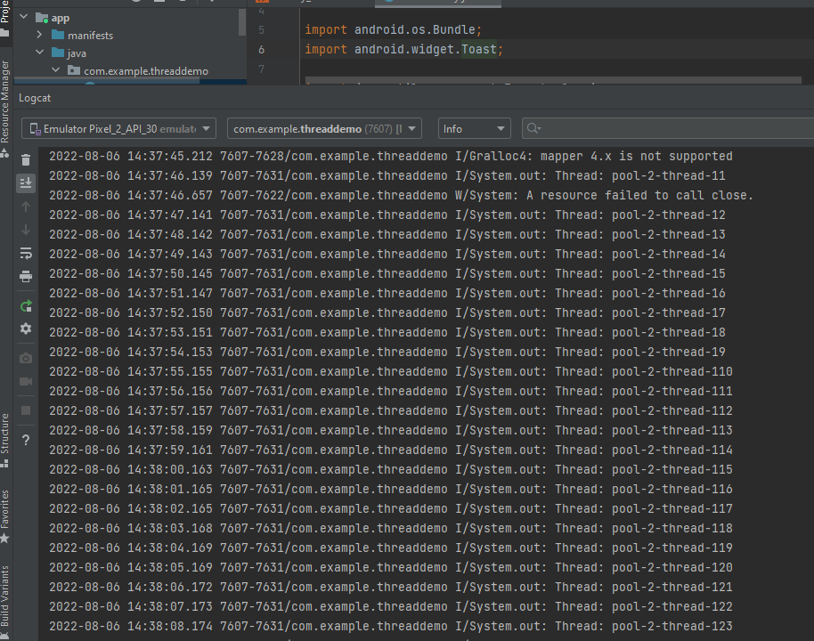

22/08/2022

DataBase insert Select

Main

package com.example.dbapp;

import androidx.appcompat.app.AppCompatActivity;

import android.os.Bundle;

import android.util.Log;

import android.view.View;

import android.widget.EditText;

import android.widget.Toast;

public class MainActivity extends AppCompatActivity {

EditText et1,et2,et3,et4,et5;

CDB db;

@Override

protected void onCreate(Bundle savedInstanceState) {

super.onCreate(savedInstanceState);

setContentView(R.layout.activity_main);

et1 = (EditText) findViewById(R.id.et1);

et2 = (EditText) findViewById(R.id.et2);

et3 = (EditText) findViewById(R.id.et3);

et4 = (EditText) findViewById(R.id.et4);

et5 = (EditText) findViewById(R.id.et5);

db = new CDB(this);

}

public void onSave(View v)

{

String dn,dl;

dn = et2.getText().toString();

dl = et3.getText().toString();

Toast.makeText(getApplicationContext(),dn + dl, Toast.LENGTH_SHORT).show();

db.addDept(dn,dl);

et1.setText("");

et2.setText("");

et3.setText("");

}

public void onFind(View v)

{

String s[];

try{

String dno = et1.getText().toString();

s = db.getOneDept(Integer.parseInt(dno));

if(s[0] != "") {

et4.setText(s[0]);

et5.setText(s[1]);

}

else

Toast.makeText(getApplicationContext(), "Record Not Found... ", Toast.LENGTH_SHORT).show();

}

catch (Exception ex)

{

Log.d("SELECT: ", ex.toString());

}

}

}

Main XML

<?xml version="1.0" encoding="utf-8"?>

<androidx.constraintlayout.widget.ConstraintLayout xmlns:android="http://schemas.android.com/apk/res/android"

xmlns:app="http://schemas.android.com/apk/res-auto"

xmlns:tools="http://schemas.android.com/tools"

android:layout_width="match_parent"

android:layout_height="match_parent"

tools:context=".MainActivity">

<LinearLayout

android:layout_width="409dp"

android:layout_height="729dp"

android:orientation="vertical"

tools:layout_editor_absoluteX="1dp"

tools:layout_editor_absoluteY="1dp">

<TextView

android:id="@+id/tv1"

android:layout_width="match_parent"

android:layout_height="wrap_content"

android:text="Insertion in to DataBase"

android:textSize="20sp" />

<EditText

android:id="@+id/et2"

android:layout_width="match_parent"

android:layout_height="wrap_content"

android:ems="10"

android:inputType="textPersonName" />

<EditText

android:id="@+id/et3"

android:layout_width="match_parent"

android:layout_height="wrap_content"

android:ems="10"

android:inputType="textPersonName" />

<Button

android:id="@+id/btn1"

android:layout_width="match_parent"

android:layout_height="wrap_content"

android:onClick="onSave"

android:text="INSERT" />

<TextView

android:id="@+id/tv2"

android:layout_width="match_parent"

android:layout_height="wrap_content"

android:text="Selection from DataBase"

android:textSize="20sp" />

<EditText

android:id="@+id/et1"

android:layout_width="match_parent"

android:layout_height="wrap_content"

android:ems="10"

android:inputType="textPersonName" />

<EditText

android:id="@+id/et4"

android:layout_width="match_parent"

android:layout_height="wrap_content"

android:ems="10"

android:inputType="textPersonName" />

<EditText

android:id="@+id/et5"

android:layout_width="match_parent"

android:layout_height="wrap_content"

android:ems="10"

android:inputType="textPersonName" />

<Button

android:id="@+id/btn2"

android:layout_width="match_parent"

android:layout_height="wrap_content"

android:onClick="onFind"

android:text="SELCET" />

</LinearLayout>

</androidx.constraintlayout.widget.ConstraintLayout>

CDB Java

package com.example.dbapp;

import android.content.ContentValues;

import android.content.Context;

import android.database.Cursor;

import android.database.sqlite.SQLiteDatabase;

import android.database.sqlite.SQLiteOpenHelper;

import android.util.Log;

public class CDB extends SQLiteOpenHelper{

private static final int DATABASE_VERSION = 1;

private static final String DATABASE_NAME = "DMS";

public CDB(Context context)

{

super(context,DATABASE_NAME,null,DATABASE_VERSION);

}

@Override

public void onCreate(SQLiteDatabase sqLiteDatabase) {

sqLiteDatabase.execSQL("create table TbDept(dno integer primary key autoincrement, dname text, dloc text)");

}

@Override

public void onUpgrade(SQLiteDatabase sqLiteDatabase, int i, int i1) {

sqLiteDatabase.execSQL("drop table if exists TbDebt");

onCreate(sqLiteDatabase);

}

public void addDept(String dn, String dl)

{

try

{

SQLiteDatabase db = this.getWritableDatabase();

ContentValues cv = new ContentValues();

cv.put("dname",dn);

cv.put("dloc",dl);

db.insert("TbDept",null,cv);

db.close();

}

catch (Exception e)

{

System.out.println(e);

Log.d("INSERT: ",e.toString());

}

}

public String[] getOneDept(int dno)

{

String[] a = new String[2];

try{

SQLiteDatabase db = this.getReadableDatabase();

Cursor cursor = db.query("TbDept", new String[]{"dno","dname","dloc"},"dno" + "=?",

new String[]{String.valueOf(dno)},null,null,null,null);

if(cursor != null && cursor.getCount() !=0)

{

cursor.moveToFirst();

a[0] = cursor.getString(1);

a[1] = cursor.getString(2);

}

else

{

a[0]="";

a[1]="";

}

}

catch (Exception e)

{

System.out.println(e);

Log.d("SELECT: ",e.toString());

}

return a;

}

}

Output

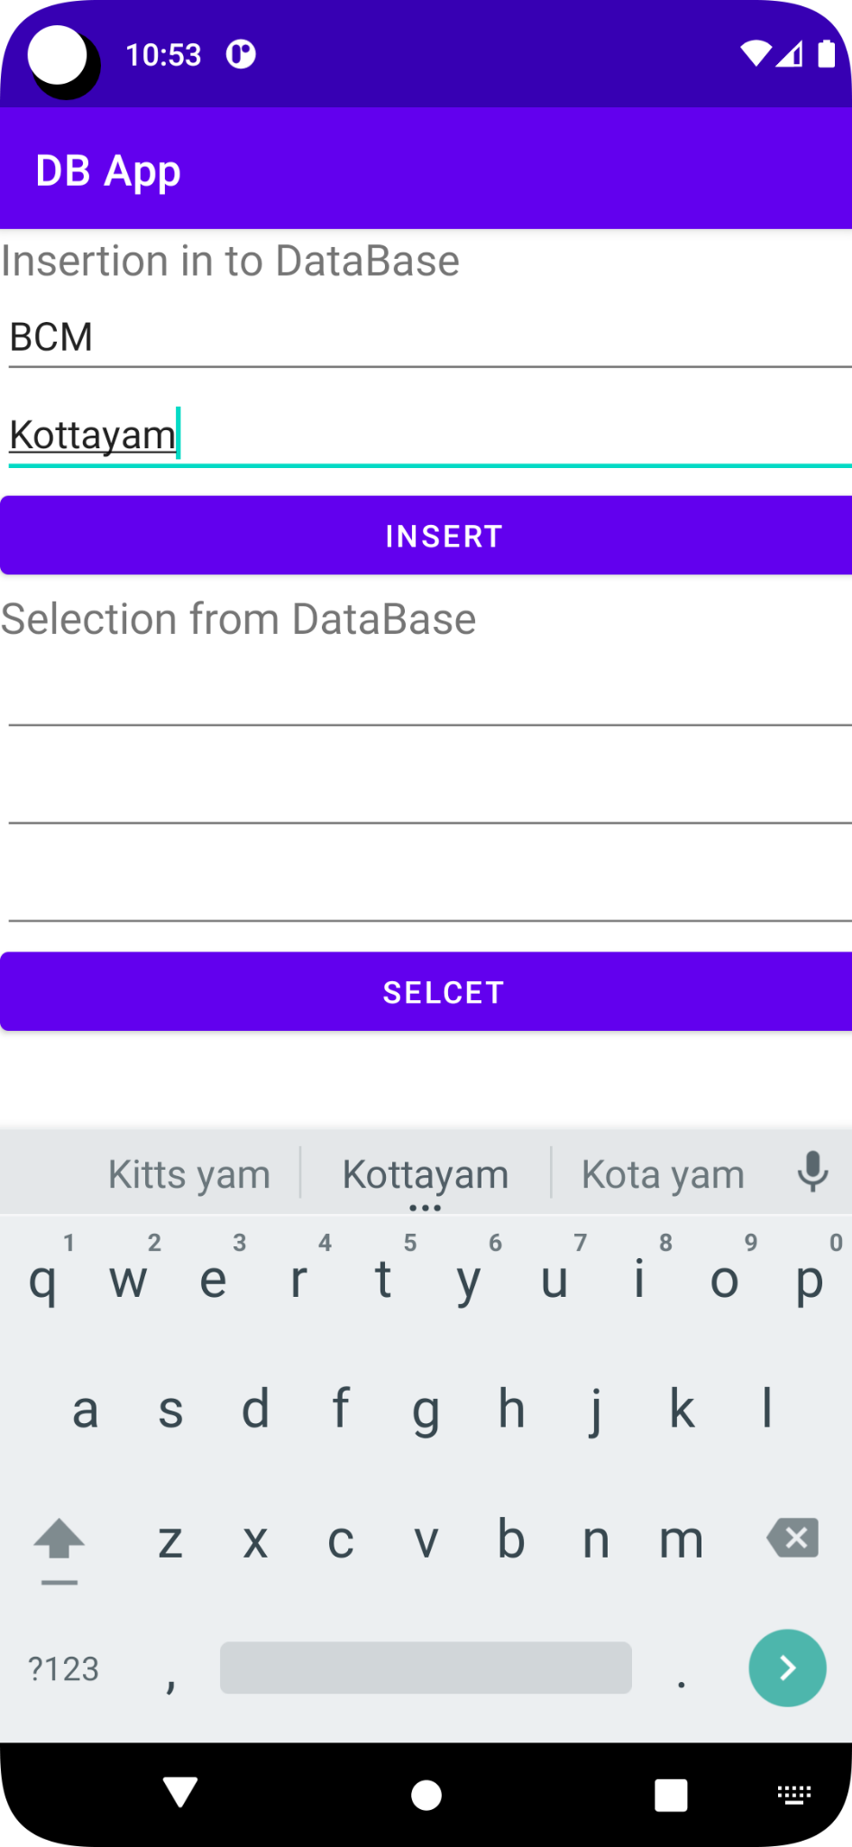

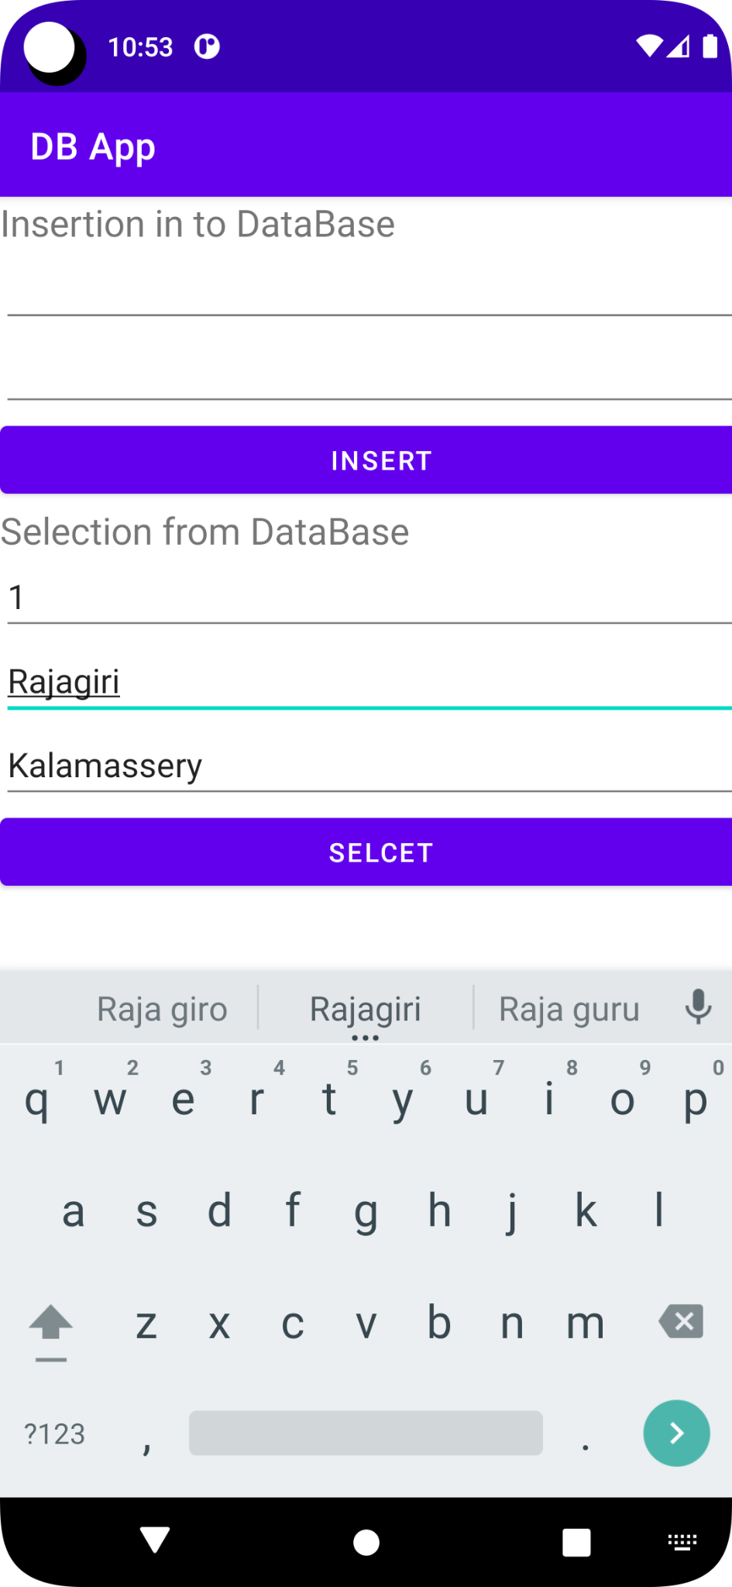

Deletion

Updation

Select all

MVC program

Json

sqLite

SQL

12/09/2022

Android app with mysql database

Database

Create database ems

CREATE table emp(eno integer auto_increment primary key, ename varchar(30), epass varchar(30));

Insert values

PHP

<?php

$eno = $_REQUEST["eno"];

$con = mysqli_connect("localhost:3306", "root","");

if(mysqli_connect_errno())

{

echo"Error ".mysqli_connect_error();

}

mysqli_select_db($con,"ems");

$result = mysqli_query($con,"select * from emp where eno=$eno");

$row = mysqli_fetch_array($result);

echo json_encode($row);

?>